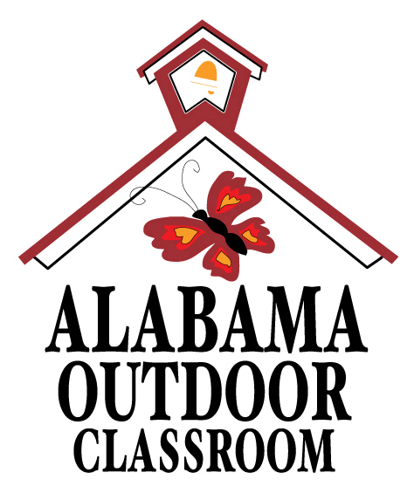
Basic Needs of Living Things: Ants, Plants & You
Name: | __________________________________________________________________  -------------------------------------------------------------------  __________________________________________________________________

Draw two living things (an ant & a plant) that you find in your outdoor classroom, and then draw a picture of yourself.
Mark an X next to the things that the ant, the plant, and YOU need to survive.
Mark an X if you can find a source of food, water, air, sun and shelter in your outdoor classroom for the ant, plant and you.

Living Things | 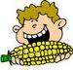  Food |   Water | 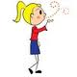  Air | 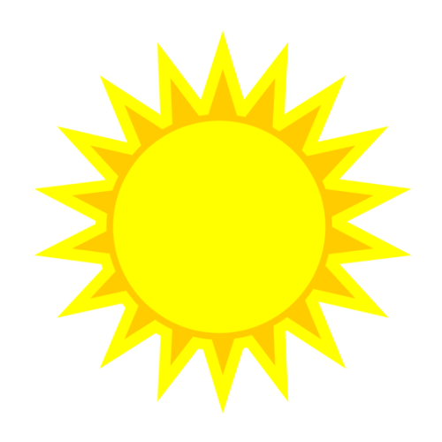  Sun | 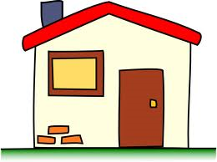  Shelter
1. Draw an Ant | bugs & leaves  Need it? ____  Find it? ____ | rain & puddles  Need it? ____  Find it? ____ | all around us  Need it? ____  Find it? ____ | sunlight  Need it? ____  Find it? ____ | leaves, rocks & soil  Need it? ____  Find it? ____
2. Draw a Plant | sun & soil  Need it? ____  Find it? ____ | rain  Need it? ____  Find it? ____ | all around us  Need it? ____  Find it? ____ | sunlight  Need it? ____  Find it? ____ | space to grow  Need it? ____  Find it? ____
3. Draw You | fruit & vegetables  Need it? ____  Find it? ____ | clean water  Need it? ____  Find it? ____ | all around us  Need it? ____  Find it? ____ | sunlight  Need it? ____  Find it? ____ | shelter from weather  Need it? ____  Find it? ____


Alabama Wildlife Federation Outdoor Classroom Field Investigation Activity Sheet: Basic Needs of Living Things v2, page 1 of 1

