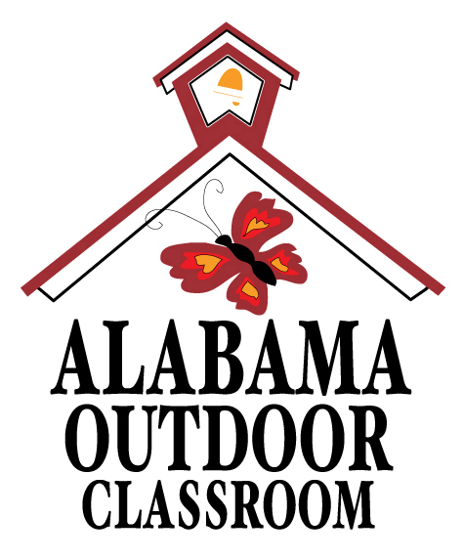
Comparing Life Cycles
Name:________________________ Date:_________________
Use field identification guides like the National Audubon’s Field Guide to the Southeastern States, the Alabama Wildlife Federation’s Wonders of Wildlife webpages, and the Outdoor Alabama’s Watchable Wildlife webpages to identify and research an animal in the outdoor classroom.
1. Draw a picture of the animal.
2. Common Name:____________________________
3. Class of Animal:____________________________
4. How do their babies start life? (circle answer)
live babies hard-shell eggs soft tiny eggs
5. What is the baby called?_____________________
6. Draw and label the animal’s life cycle stages below. Record its size for each life cycle stage, and then put a checkmark next to the life cycle stage you found.
7. Describe the physical changes that the animal goes through from birth to an adult.
_____________________________________________________________________
_____________________________________________________________________

Growing Stage
Size:_________

Adult Stage
Size:__________

- Birth or Baby
Size:_________

- Metamorphosis (if there is one)
Size:__________

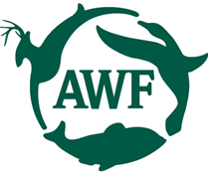
Alabama Wildlife Federation Outdoor Classroom Field Investigation Activity Sheet: Comparing Life Cycles v1, page 1 of 1

