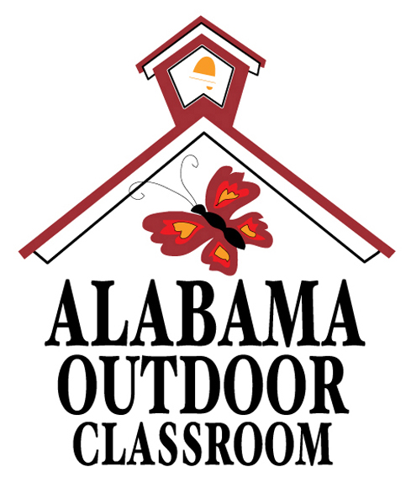
Looking for Evidence of Wildlife
We share our homes and schools with wildlife even if we do not see them.
Look for evidence of wildlife around your outdoor classroom.
Draw a picture of the evidence (such as a feather) and draw a picture of the animal it represents (such as a bird). Then use resources such as the National Audubon Society Regional Guide to the Southeastern States and Scats and Tracks of the Southeast or the Internet to help you identify the wildlife evidence you find,
and to help you determine which species of wildlife use your schoolyard as habitat (a home).
Caution – Be careful not to harm any wildlife or their habitats.
 | “Evidence” of Wildlife Species of Wildlife
Ex | blue feather with black bands bird - blue jay
1
2
3
4
5
6
7
Total Number of Evidence Found:____ Date:_________________ _____, _________

Make copies of this data sheet as needed.
Alabama Wildlife Federation Outdoor Classroom Field Investigation Worksheet: Evidence of Wildlife, page 1 of 3
Looking for Evidence of Wildlife
We share our homes and schools with wildlife even if we do not see them.
Look for evidence of wildlife around your outdoor classroom.
Describe the evidence (such as a red feather), then name the animal it represents (such as a Northern Cardinal bird) and describe the location where you found the evidence.
Then use resources such as the National Audubon Society Regional Guide to the Southeastern States and Scats and Tracks of the Southeast or the Internet to help you identify the wildlife evidence you find,
and to help you determine which species of wildlife use your schoolyard as habitat (a home).
Caution – Be careful not to harm any wildlife or their habitats.
 | Evidence of Wildlife | Species of Wildlife | Location
Ex: | Red Feather | Bird – probably Northern Cardinal | Under Bird Bath
Ex: | Animal Track / Foot Print | Raccoon | In Vegetable Garden
1
2
3
4
5
6
7
8
9
10
Total Number of Evidence Found:____ Date:_________________ _____, _________
Make copies of this data sheet as needed.
Alabama Wildlife Federation Outdoor Classroom Field Investigation Worksheet: Evidence of Wildlife, page 2 of 3
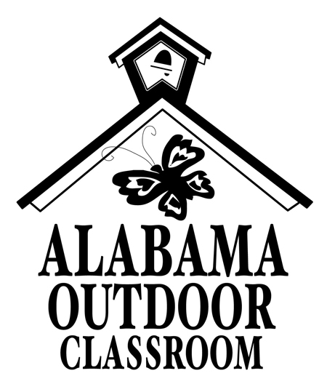
Graphing your “Evidence of Wildlife” Data
Count the number of “evidence” you found in your outdoor classroom area for birds, reptiles, amphibians, mammals, and insects, and log your data into the graph below to create a bar graph.
Number of
Evidence
Found:
16_____________________________________________________

14_____________________________________________________

12______________________________________________________

10______________________________________________________

8______________________________________________________

6______________________________________________________

4______________________________________________________

2______________________________________________________

0______________________________________________________
Type of Wildlife: | Birds | Reptiles | Amphibians | Mammals | Insects

OBSERVATION DATA for _______________ ______, __________
(Date)
For which type of wildlife did you find the most evidence?_____________
How much evidence did you find for this type of wildlife?______________
For which type of wildlife did you find the least evidence?_____________
How much evidence did you find for this type of wildlife?______________
Alabama Wildlife Federation Outdoor Classroom Field Investigation Worksheet: Evidence of Wildlife, page 2 of 2

