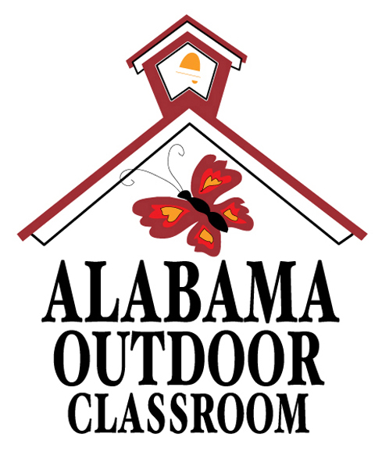
Find a Food Chain


Name:_________________________ Date: _______________
Alabama Wildlife Federation Outdoor Classroom Field Journal Activity: Find a Food Chain, 5th Grade, page 1 of 1
Part 1: Answer the questions below.
1. What is a food chain?___________________________________________________________________________
_____________________________________________________________________________________________
2. Label the part(s) of a food chain in the diagram below using the following vocabulary words (some words will not be used):
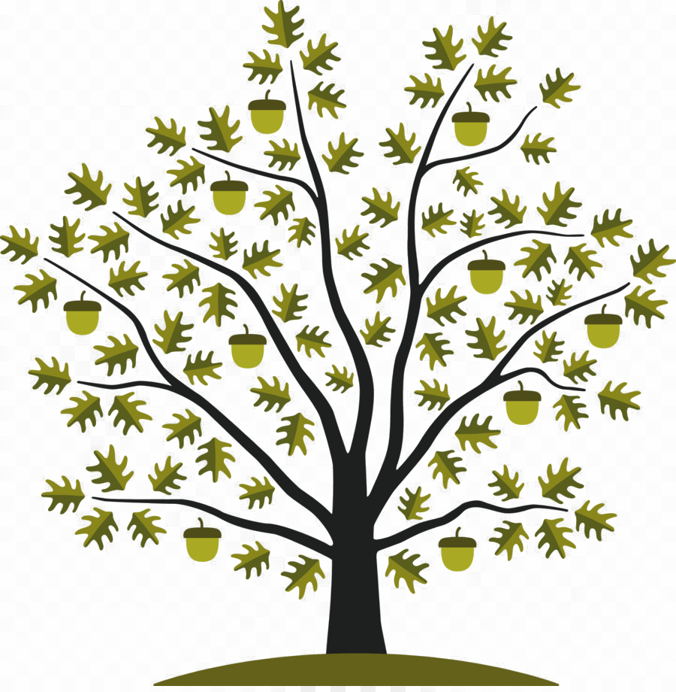
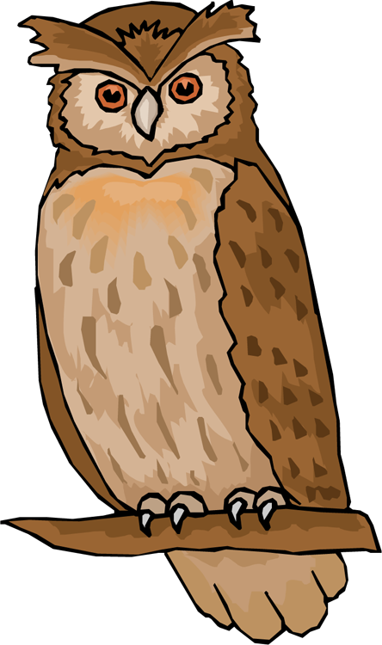
decomposer primary consumer producer secondary consumer sun tertiary consumer
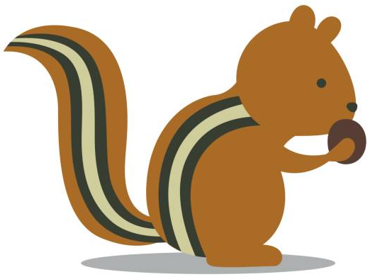
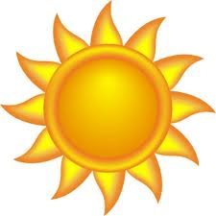
energy
energy
energy
a.
b.
c.
d.

a.____________________ b.____________________ c.____________________ d._____________________
3. How does a plant get energy from the sun?____________________________________________________________
_____________________________________________________________________________________________
4. How does an animal get its energy?_________________________________________________________________
_____________________________________________________________________________________________
Alabama Wildlife Federation Outdoor Classroom Field Investigation Activity Sheet: Find a Food Chain, v2 page 1 of 3

Part 2: Explore the outdoor classroom and look for a decomposer. Use the Example Food Chain Components chart on page 3 along with field guides like the National Audubon’s Field Guide to the Southeastern States and/or the Alabama Wildlife Federation’s Dig into Plants and Wonders of Wildlife webpages to answer the following questions:
5. What decomposer did you find in the outdoor classroom?_________________________________________________
_____________________________________________________________________________________________
6. How does it get its energy to survive and reproduce?____________________________________________________
_____________________________________________________________________________________________
7. How does it provide energy for other living organisms?__________________________________________________
_____________________________________________________________________________________________
8. Draw a picture of the decomposer you found in the circle below where it would be located in a food chain. Next, fill in the other links with animal(s) or plant(s) in the food chain of the decomposer you found, and then draw and label them using the vocabulary words in the box below. The arrows show the flow of energy through the food chain.
a.
b.
c.
d.
e.

a.________________ b.________________ c. ________________ d.________________ e.________________

f.________________
Alabama Wildlife Federation Outdoor Classroom Field Investigation Activity Sheet: Find a Food Chain, v2 page 2 of 3
f.
decomposer primary consumer producer secondary consumer sun tertiary consumer

EXAMPLE FOOD WEB COMPONENTS
(A component is one part or element of the larger whole.)
Plants  (Producers) | Herbivores  (Primary Consumers) | Omnivores  (Secondary/Tertiary Consumers) | Carnivores  (Secondary/Tertiary Consumers) | Detritivores & Fungus  (Decomposers)
Grasses | Armyworms | Ants | Spiders | Mushrooms
Wildflowers | Caterpillars | Wasps | Fleas | Worms
Herbs | Butterflies | Lady Bugs | Ticks | Spiders
Shrubs | Bees | Crickets | Bats | Ants
Trees | Moths | Mosquitos | Snakes | Flies
Nuts | Grasshoppers | Songbirds | *Alligators | Beetles
Berries | Treehoppers | Squirrels & Chipmunks | *Some Fish | Millipedes
Acorns | Leafhoppers | Opossums | *Owls | Pill Bugs/Roly Polies
Pinecones | Katydids | Racoons | *Bobcats | Cockroaches
Seeds | Deer | Skunks | *Hawks | Snails
Fruits | Beavers | Frogs & Toads |  | Slugs
Aquatic plants | Rabbits | Salamanders
Algae | Some Fish | Turtles
 |  | Lizards
 |  | *Foxes (Red and Gray)
 |  | *Coyotes
 | Alabama Wildlife Federation Outdoor Classroom Field Investigation Answer Sheet: Find a Food Chain, v2 page 3 of 3 | *Black Bears |  | *Apex Predators

