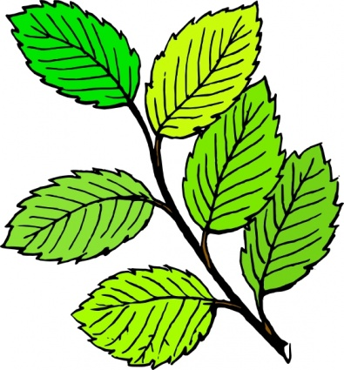
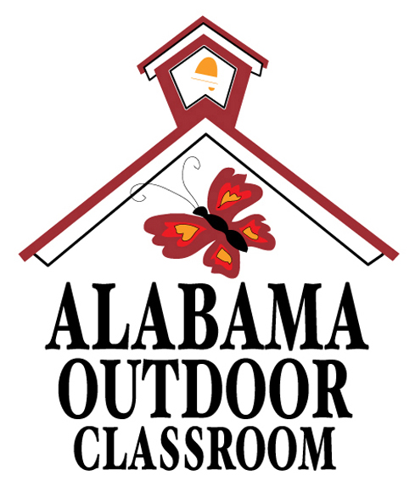
Observing a Leaf
Name: | __________________________________________________________________  -------------------------------------------------------------------  __________________________________________________________________
Pick a leaf in the outdoor classroom.

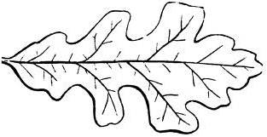
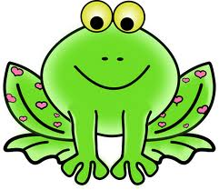
Trace the leaf with a pencil or make a rubbing of it with a crayon in the box below.
Put stem of leaf on this end of box.
- - - - - - - - - - - - - - - - - - - - - - - - - - - - - - - - -

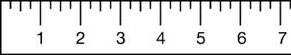 inches

Using the ruler, how long is your leaf in inches?_______________

Next, cut out the frog and use it to measure your leaf.

How long is your leaf in “frogs”?_______________
(Your leaf should be the same number of inches and “frogs” in length, as the frog equals one inch.)

Alabama Wildlife Federation Outdoor Classroom Field Investigation Worksheet: Observing a Leaf, page 1 of 2
Put the stem of the leaf on the dotted line on the left side of the box with the tip of the leaf pointing to the right side of the box so that you can measure it. For example, see the leaf below…

Look at your leaf.
What color is it? | ___________________________________________  ---------------------------------------------  ___________________________________________
What shape does it look like? |  | ___________________________________________  ---------------------------------------------  ___________________________________________

- circle | - oval | - square | - rectangle
- triangle | - heart | - star | - diamond

Feel your leaf.
How does it feel? | ___________________________________________  ---------------------------------------------  ___________________________________________

- smooth | - bumpy | - rough | - prickly
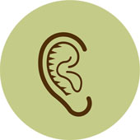
Crush your leaf in your hand.
Does it make a noise? | - yes | - no | Is it crunchy?  Is it dead? | - yes  - yes | - no  - no
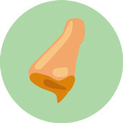
Smell your leaf.
How does it smell? |   - sweet |   - stinky | - no smell
Write a sentence describing your leaf.
________________________________________________________________
________________________________________________________________
Alabama Wildlife Federation Outdoor Classroom Field Investigation Worksheet: Observing a Leaf, page 2 of 2

