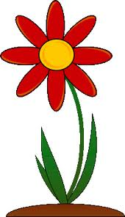

Parts of a Plant
Name:__________________________

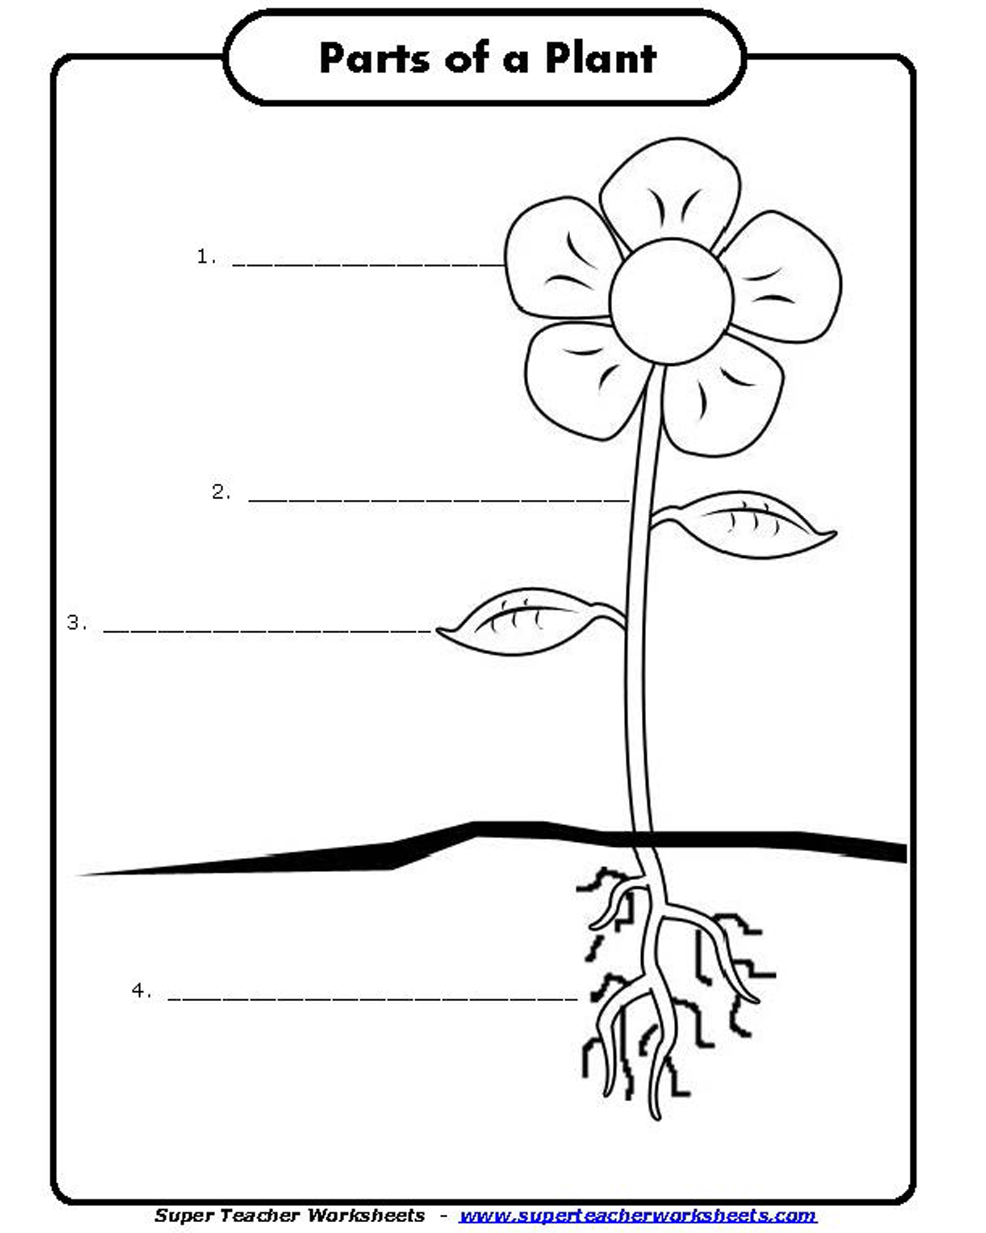
The _______________ makes the seeds for new plants to grow.
The ____________ supports the plant. It contains thin tubes for carrying food, minerals, and water.
The ______________ make food for the plant by using sunlight. They take in carbon dioxide and release oxygen into the air.
The _______________ soak up water and minerals. They also store food for the plant.

Alabama Wildlife Federation Outdoor Classroom Field Investigation Worksheet: Parts of a Plant, page 1 of 2

Go into your outdoor classroom. Find 2 different plants with
Plant #1
Plant #2
flowers on them. Draw pictures of them, and label their parts.

Do their flowers look, feel and smell the same? __ yes __ no
Explain:__________________________________________________
________________________________________________________

Do their stems look and feel the same? __ yes __ no
Explain:__________________________________________________
________________________________________________________

Do their leaves look and feel the same? __ yes __ no
Explain:__________________________________________________
________________________________________________________
Alabama Wildlife Federation Outdoor Classroom Field Investigation Worksheet: Parts of a Plant, page 2 of 2

