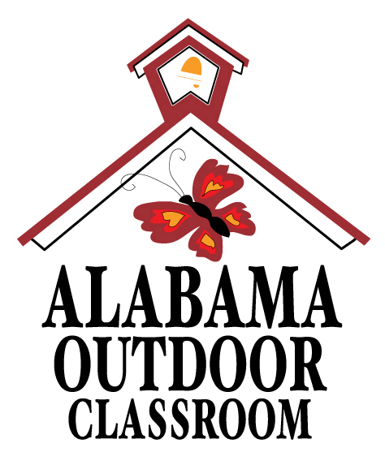
Basic Needs of Living Things: Ants, Plants & You
Name: | __________________________________________________________________  -------------------------------------------------------------------  __________________________________________________________________

Draw a picture of an ant, a plant, and a picture of yourself.
Circle the food, water, air, sun and shelter that you can find in your outdoor classroom for ants, plants and you.

Living Things | Food | Water | Air | Sun | Shelter
1. Draw an Ant |   bugs & leaves | rain & puddles  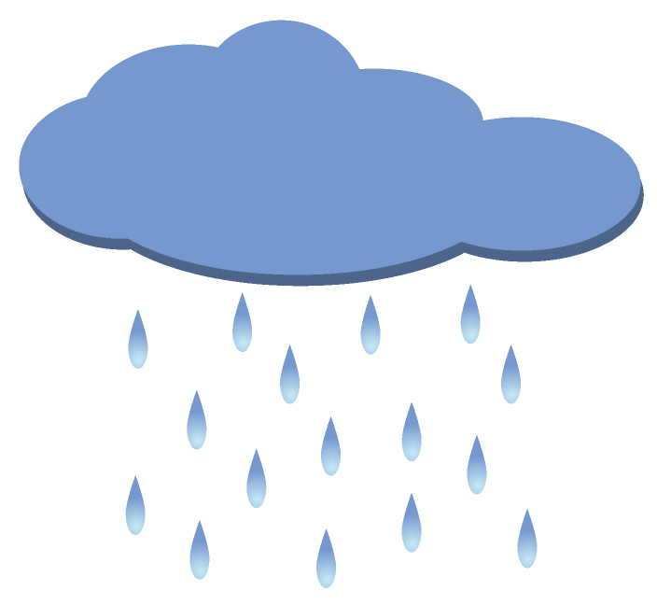 |   all around us | 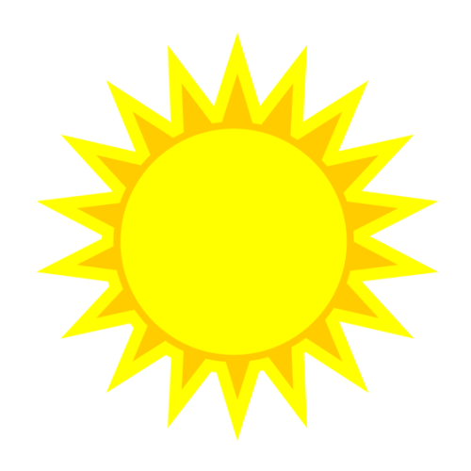  sunlight | 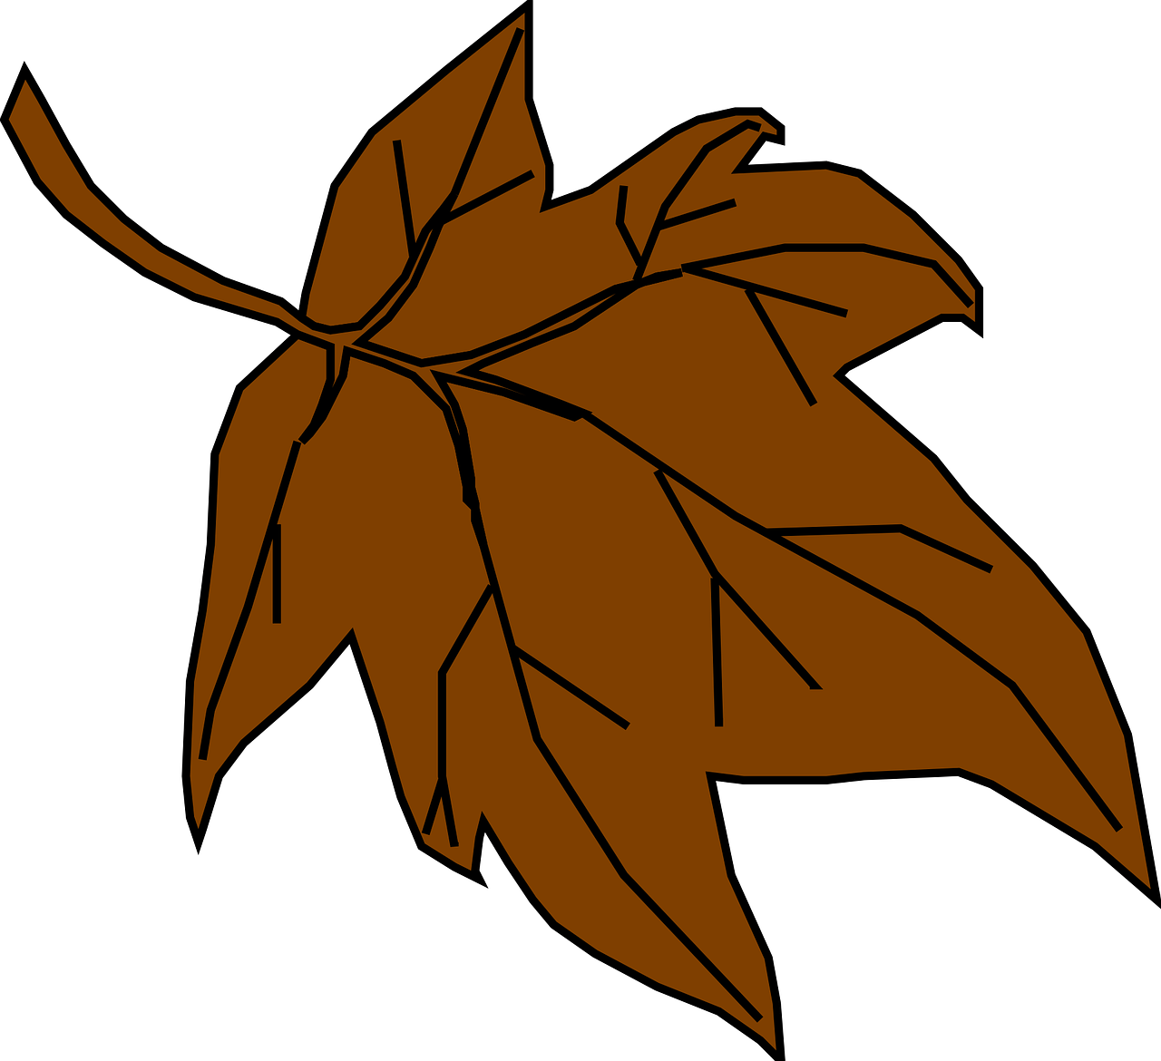  leaves, rocks & soil
2. Draw a Plant | 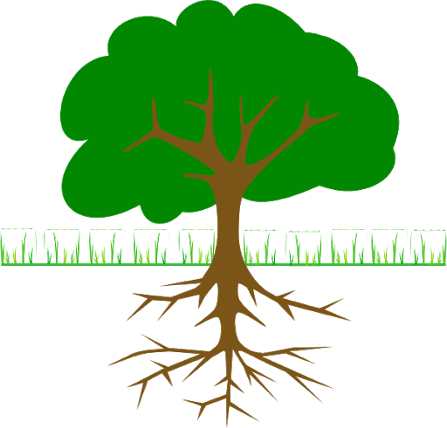  Food in soil | rain | all around us | sunlight | space to grow  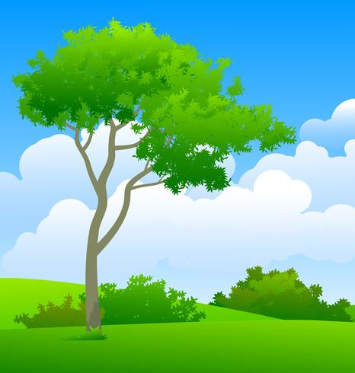
3. Draw You | 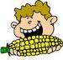  fruit & vegetables |   clean water | all around us | sunlight | shelter from weather  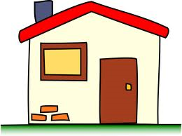

Alabama Wildlife Federation Outdoor Classroom Field Investigation Activity Sheet: Basic Needs of Living Things v2, page 1 of 1

