**Outdoor Classroom Project Plan:**

**Materials List & Budget for**

**Example Frog & Toad Habitat**

A Frog and Toad Habitat should provide food sources, water, shelter, and places for frogs and toads to lay their eggs which will become tadpoles. To meet their habitat needs, this learning station will consist of two features built together as one habitat:

1. **Frog Pond** – A frog pond should have shallow water where frogs and toads can lay their eggs. In an outdoor classroom, the frog pond can be a pre-formed plastic pond that is approximately 3 to 4 feet in diameter and 10 to12 inches deep with 8 to 10 inches of water and one or two pots of native marginal aquatic plants such as pickerelweed, lizard tail, arrow arum, or horsetail.
2. **Bog Garden** – A bog is a type of wetland in a low-lying area where water collects, often times depositing dead, decaying plant matter. Flora and fauna that thrive in a bog area prefer a moist environment, but do not require standing water (like a pond, marsh or swamp) unless the bog area recently experienced heavy rains and has not yet drained. An example bog garden can be created in your outdoor classroom by digging a hole in the ground that is 11 ft long, 8 ft wide, and 12 inches deep, placing a 10 ft x 13 ft pond liner in the hole, and filling it with layers of peat moss, sand, and compost. See page 3 for bog plant suggestions and construction instructions.

* **Location Requirements:**
* **Area near a Downspout and/or Spigot** (so that you can divert rain water into the habitat and/or fill the pond and bog with water during low rain levels)
* **Flat Area** (so the soil in the bottom of the bog will not flow out of the pond in a heavy rain)
* **Area Approved for Digging** (must not have any utility lines under the area)
* **Full to Part Shade** (be sure to choose the appropriate plants based on your sunlight conditions)
* 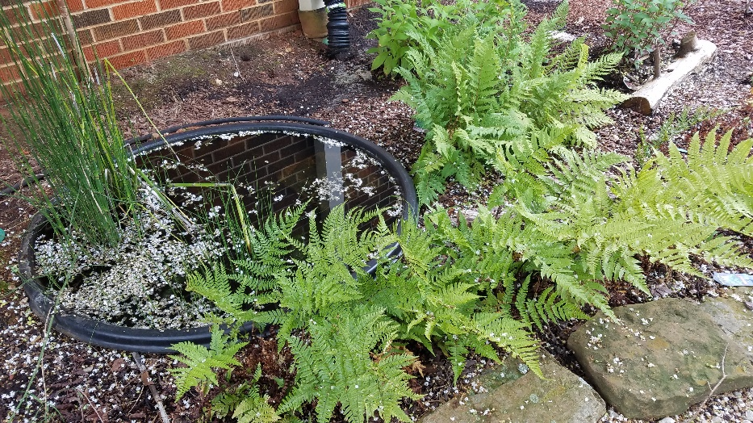**Example Frog & Toad Habitats:**

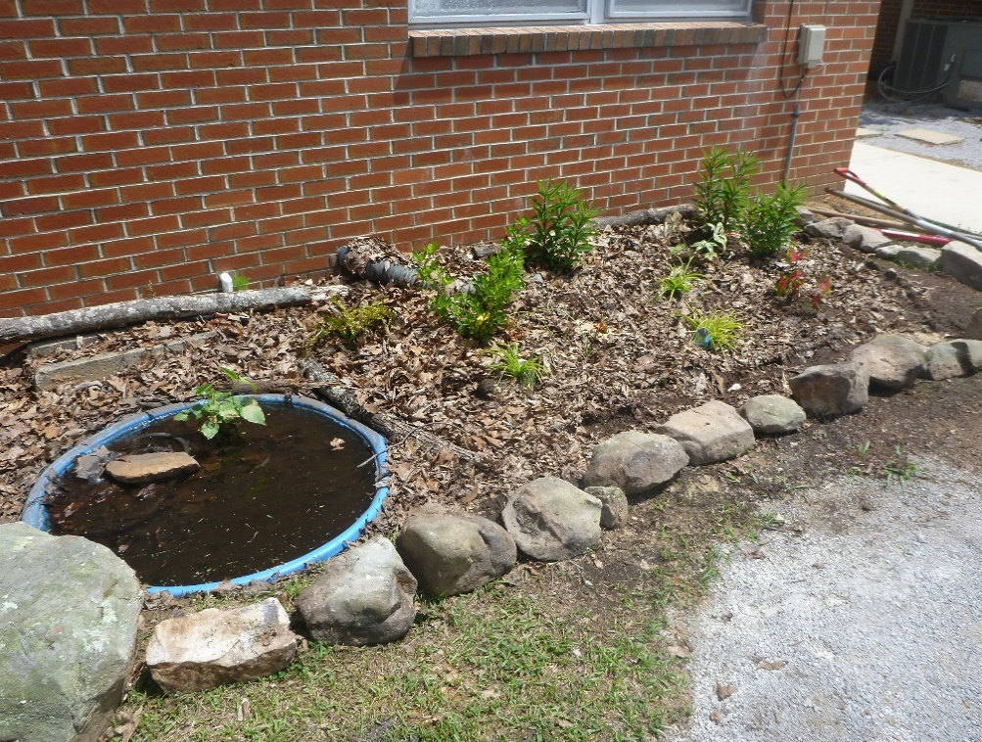

**OC Project Plan: Example Frog & Toad Habitat Materials List & Budget**

* **Estimated Cost:**
* Small Frog and Toad Habitat (4 ft x 8 ft x 1 ft 🡪 32 CF): $1,015-$1,250
* Large Frog and Toad Habitat (8 ft x 11 ft x 1 ft 🡪 88 CF): $1,530-$1,790
* **Materials & Supplies with Estimated Budget:**

|  |  |  |  |  |  |
| --- | --- | --- | --- | --- | --- |
| **Example (4 ft x 8 ft) Frog and Toad Habitat Materials Budget** | | | | | |
| **Station** | **Materials & Supplies** | **Estimated Cost** | **Source of Materials** | | **Final Cost** |
| Sm. Frog | (1) Can of Rust-Oleum Professional White Water-based Marking Paint @ ~$9.98 ea | $10 | | Lowe’s Item #429750 |  |
| Sm. Frog | (1) Smartpond 10-ft x 7-ft (200-Gallon) Black PVC Pond Liner (~14.5 mil thick) @ ~$49.98 ea | $50 | | Lowe’s Item #61250 |  |
| Sm. Frog | (1) 3 CF Bag of Fafard Sphagnum Peat Moss Organic Moisture Control (1 bag expands to 6 CF; will only use 1/2 of the bag for the bog) @ ~$19.98 ea | $20 total | | Lowe’s Item #674760 |  |
| Sm. Frog | (18) .5 CF/50 Lb Bags of American Countryside All-purpose Sand @ ~$5.18 ea | $95 total | | Lowe’s Item #104898 |  |
| Sm. Frog | (4) 32-Quart (1CF) Bags of Evergreen Organic Potting Soil Mix @~$6.38 ea | $25 total | | Lowe’s Item #380608 |  |
| Sm. Frog | (7) 1 CF/32 Qt Bags of Evergreen Organic Top Soil @ ~$2.18 ea | $15 total | | Lowe’s Item #648834 |  |
| Sm. Frog | (1) 1 CF Bags of Evergreen Organic Compost and Manure @~$3.68 ea | $5 | | Lowe’s Item #380606 |  |
| Sm. Frog | (4) 2 CF Bag of Evergreen Organic Drainage and Aeration Soil Conditioner @ ~$4.58 ea | $20 total | | Lowe’s Item #648829 |  |
| Sm. Frog | (9) Bog plants (4 wildflowers @ $7 ea (2 plants of 2 different species) and 2 ferns@ $10 ea, and 3 groundcover plants @ $7 ea (for berm) – see list below) | $65 total | | Nursery via OC Consultant |  |
| Sm. Frog | (1) Aquatic Plants (see list below) | $15 | | Nursery via OC Consultant |  |
| Sm. Frog | (1) Virginia Sweetspire …or… Clethra Bush | $30 | | Nursery via OC Consultant |  |
| Sm. Frog | (1) EarthMinded FlexiFit Universal Diverter System (to divert downspout water into rain barrel or to the hose that links to the buried soaker hose) @ ~$35.95 ea | $35 | | <https://www.therainbarreldepot.com/earthminded-universal-diverter-system/> |  |
| Sm. Frog | (1) 50-gallon RTS Home Accents Flat Back Brown Rain Barrel (*optional – helps slow flow of rain water and holds water for future watering) @ ~$209.00 ea | $210 | | Lowe’s Item #4057929 |  |
| Sm. Frog | (1) RTS Home Accents Black Rain Barrel Stand - (*optional – helps elevate spigot to increase water flow out of barrel and allow for room for buckets to catch water coming out of barrel) @ ~$72.98 ea | $75 | | Lowe’s Item #4057926 |  |
| Sm. Frog | (1) 5/8-in x 6-ft FLEXON Light-Duty Vinyl Green Hose @ ~$11.98 ea | $10 | | Lowe’s Item #812743 |  |

**OC Project Plan: Example Frog & Toad Habitat Materials List & Budget**

* **Materials & Supplies with Estimated Budget (cont.):**

|  |  |  |  |  |
| --- | --- | --- | --- | --- |
| Sm. Frog | (1) 3/8-in x 25-ft-Element Kink Free Rubber Black Soaker Hose @ ~$15.98 ea | $15 | Lowe’s Item #2626704 |  |
| Sm. Frog | (21) 11-in L x 4-in H x 6-in D Flagstone Concrete Retaining Wall Blocks (trapezoid-shaped to create 32’ border around berm and 2 steps in pond) @ ~$2.88 ea | $60 total | Lowe’s Item #477095 |  |
| Sm. Frog | (10) Old Manor 12-in L x 4-in H x 8-in D Concrete Retaining Wall Blocks (to place along the sides of the berm) @~$2.88 ea | $30 total | Lowe’s Item #477088 |  |
| Sm. Frog | (2) .5 CF Bag of 1” American Countryside 0.5-cu ft River Rock Gravel @ ~$5.18 ea | $10 total | Lowe’s Item #2623 |  |
| Sm. Frog | (1) 3.91-ft diameter x 12” deep (64 gal) MacCourt Black High Density Polyethylene Pre-formed Pond @ ~$253.12 ea  **…OR…**  (1) 2.16 ft diameter (9 gal) MacCourt Black High Density Polyethylene Pre-formed Pond @ ~$18.28 ea | $255  **…OR…**  $20 | Lowe’s Item #447801  **…OR…**  Lowe’s Item #1176703 |  |
| Sm. Frog | (1) TetraPond Pond Spitter Decoration and Pond Aerator @~$24.97 ea | $25 | <https://www.amazon.com/TetraPond-Pond-Spitter-Decoration-Aerator/dp/B00U0K7SSC/ref> |  |
| Sm. Frog | (1) Smartpond® Low Water Shut-off 80-GPH Submersible Fountain Pump @ ~$25.98 ea | $25 | Lowe’s Item #2566875 |  |
| Sm. Frog | (1) EZ-FLO Clear Vinyl Tubing (1/2-in ID x 10 ft) (to connect pump to spitter) @~$6.88 ea | $5 | Lowe’s Item #814319 |  |
| Sm. Frog | Educational Sign about Life Cycle of a Frog | $75 | Ask OC Consultant about <https://www.alabamawildlife.org/oc-signs/> |  |
| Sm. Frog | (1) 6 ft. U-Post for Fence (*for educational sign*) @~$10.69 ea | $10 | Lowe’s Item #493054 |  |
| Sm. Frog | (1) Hillman 1/4-in x 1-1/2-in Zinc-Plated Coarse Thread Hex Bolt (2-Count) @~$0.88 ea | $5 total | Lowe’s Item #137634 |  |
| Sm. Frog | (2) Hillman 1/4-in x 20 Zinc-Plated Steel Hex Nut @~$0.10 ea | Lowe’s Item #63301 |  |
| Sm. Frog | (2) Hillman 1/4-in Zinc-plated Standard Flat Washer @~$0.15 ea | Lowe’s Item #63306 |  |
| Sm. Frog | (6) Plant ID Signs @ ~$6 ea | $35 total | <https://www.alabamawildlife.org/oc-dig-into-plants/> for details |  |
| Sm. Frog | (6) Biomarkers to hold Plant ID signs (13” stakewith a 2” x 4” plate) @ ~$3 ea (*includes S&H*) | $20 total | AWF OC Consultant or <https://mcgbiomarkers.com/shop/> |  |
| **TOTAL ESTIMATED COST: $1,015- $1,250** | | | | |

**OC Project Plan: Example Frog & Toad Habitat Materials List & Budget**

|  |  |  |  |  |  |  |
| --- | --- | --- | --- | --- | --- | --- |
| **Example (8 ft x 11 ft) Frog and Toad Habitat Materials Budget** | | | | | | |
| **Station** | **Materials & Supplies** | **Estimated Cost** | | **Source of Materials** | | **Final Cost** |
| Lg. Frog | (1) Can of Rust-Oleum Professional White Water-based Marking Paint @ ~$9.98 ea | | $10 | | Lowe’s Item #429750 |  |
| Lg. Frog | (1) Smartpond 13-ft x 10-ft (600-Gallon) Black PVC Pond Liner (~8 mil thick) @ ~$83.98 ea | | $85 | | Lowe’s Item #62415 |  |
| Lg. Frog | (1) 3 CF Bag of Fafard Sphagnum Peat Moss Organic Moisture Control (1 bag expands to 6 CF) @ ~$19.98 ea | | $20 | | Lowe’s Item #674760 |  |
| Lg. Frog | (48) .5 CF/50 Lb Bags of American Countryside All-purpose Sand @ ~$5.18 ea | | $250 total | | Lowe’s Item# 104898 |  |
| Lg. Frog | (11) 32-Quart (1CF) Bags of Evergreen Organic Potting Soil Mix @~$6.38 ea | | $70 total | | Lowe’s Item #380608 |  |
| Lg. Frog | (21) 1 CF/32 Qt Bags of Evergreen Organic Top Soil @ ~$2.18 ea | | $45 total | | Lowe’s Item #648834 |  |
| Lg. Frog | (2) 1 CF Bags of Evergreen Organic Compost and Manure @~$3.68 ea | | $5 total | | Lowe’s Item #380606 |  |
| Lg. Frog | (12) 2 CF Bag of Evergreen Organic Drainage and Aeration Soil Conditioner @ ~$4.58 ea | | $55 total | | Lowe’s Item #648829 |  |
| Lg. Frog | (26) Bog plants (12 wildflowers @ $7 ea (3 plants of 4 different species) and 6 ferns@ $10 ea (3 of 2 diff species) and 8 groundcover plants @ $7 ea (for berm) – see list below) | | $200 total | | Nursery via OC Consultant |  |
| Lg. Frog | (1 or 2) Aquatic Plants (1 or 2 species - see list below) | | $15 or $30 | | Nursery via OC Consultant |  |
| Lg. Frog | (1) Virginia Sweetspire …or… Clethra Bush | | $30 | | Nursery via OC Consultant |  |
| Lg. Frog | (1) EarthMinded FlexiFit Universal Diverter System (to divert downspout water into rain barrel or to the hose that links to the buried soaker hose) @ ~$35.95 ea | | $35 | | <https://www.therainbarreldepot.com/earthminded-universal-diverter-system/> |  |
| Lg. Frog | (1) 50-gallon RTS Home Accents Flat Back Brown Rain Barrel (*optional – helps slow flow of rain water and holds water for future watering) @ ~$209.00 ea | | $210 | | Lowe’s Item #4057929 |  |
| Lg. Frog | (1) RTS Home Accents Black Rain Barrel Stand - (*optional – helps elevate spigot to increase water flow out of barrel and allow for room for buckets to catch water coming out of barrel) @ ~$72.98 ea | | $75 | | Lowe’s Item #4057926 |  |
| Lg. Frog | (1) 5/8-in x 6-ft FLEXON Light-Duty Vinyl Green Hose @ ~$11.98 ea | | $10 | | Lowe’s Item #812743 |  |
| Lg. Frog | (1) 3/8-in x 25-ft-Element Kink Free Rubber Black Soaker Hose @ ~$15.98 ea | | $15 | | Lowe’s Item #2626704 |  |

**OC Project Plan: Example Frog & Toad Habitat Materials List & Budget**

* **Materials & Supplies with Estimated Budget (cont.):**

|  |  |  |  |  |
| --- | --- | --- | --- | --- |
| Lg. Frog | (50) 11-in L x 4-in H x 6-in D Flagstone Concrete Retaining Wall Blocks (trapezoid-shaped to create 32’ border around berm and 2 steps in pond) @ ~$2.88 ea | $145 total | Lowe’s Item #477095 |  |
| Lg. Frog | (2) .5 CF Bag of 1” American Countryside 0.5-cu ft River Rock Gravel @ ~$5.18 ea | $10 | Lowe’s Item #2623 |  |
| Lg. Frog | (1) 3.91-ft diameter x 12” deep (64 gal) MacCourt Black High Density Polyethylene Pre-formed Pond @ ~$253.12 ea  **…OR…**  (1) 2.16 ft diameter (9 gal) MacCourt Black High Density Polyethylene Pre-formed Pond @ ~$18.28 ea | $255  **…OR…**  $20 | Lowe’s Item #447801  **…OR…**  Lowe’s Item #1176703 |  |
| Lg. Frog | (1) TetraPond Pond Spitter Decoration and Pond Aerator @~$24.97 ea | $25 | <https://www.amazon.com/TetraPond-Pond-Spitter-Decoration-Aerator/dp/B00U0K7SSC/ref> |  |
| Lg. Frog | (1) Smartpond® Low Water Shut-off 80-GPH Submersible Fountain Pump @ ~$25.98 ea | $25 | Lowe’s Item #2566875 |  |
| Lg. Frog | (1) EZ-FLO Clear Vinyl Tubing (1/2-in ID x 10 ft) (to connect pump to spitter) @~$6.88 ea | $10 | Lowe’s Item #814319 |  |
| Lg. Frog | Educational Sign about Life Cycle of a Frog | $75 | Ask OC Consultant about <https://www.alabamawildlife.org/oc-signs/> |  |
| Lg. Frog | (1) 6 ft. U-Post for Fence (*for educational sign*) @~$10.69 ea | $10 | Lowe’s Item #493054 |  |
| Lg. Frog | (1) Hillman 1/4-in x 1-1/2-in Zinc-Plated Coarse Thread Hex Bolt (2-Count) @~$0.88 ea | $5 total | Lowe’s Item #137634 |  |
| Lg. Frog | (2) Hillman 1/4-in x 20 Zinc-Plated Steel Hex Nut @~$0.10 ea | Lowe’s Item #63301 |  |
| Lg. Frog | (2) Hillman 1/4-in Zinc-plated Standard Flat Washer @~$0.15 ea | Lowe’s Item #63306 |  |
| Lg. Frog | (8 or 9) Plant ID Signs @ ~$6 ea | $50 or $55 total | <https://www.alabamawildlife.org/oc-dig-into-plants/> for details |  |
| Lg. Frog | (8 or 9) Biomarkers to hold Plant ID signs (13” stakewith a 2” x 4” plate) @ ~$3 ea (*includes S&H*) | $25-30 total | AWF OC Consultant or <https://mcgbiomarkers.com/shop/> |  |
| **TOTAL ESTIMATED COST: $1,530 - $1,790** | | | | |

* **OC Project Plan: Example Frog & Toad Habitat Materials List & Budget**
* **Frog and Toad Habitat Native Plant Suggestions:**

Customized plant identification signs with unique QR Codes that you can scan to open plant species’ webpages on AWF's website are available for the **bolded species below**. The webpages provide specific information about that plant species including a description of the plant, the ecological benefits that species provides, maintenance tips, and photos of the plant including its leaves, flowers & seeds.

|  |  |  |  |
| --- | --- | --- | --- |
| **Aquatic Plants** | | | |
| Arrow Arum | **Horsetail** | **Lizard’s Tail** | Pickerelweed |
| **Bog Plants** | | | |
| **Blue Cardinal Flower** | **Christmas Fern** | Cinnamon Fern | **Eastern Red Columbine** |
| **Great Blue Lobelia** | **Heartleaf Foam Flower** | **Joe-pye Weed** | **Lady Fern** |
| **Southern Woodfern** | **Spiderwort** | **Stokes Aster** | **Swamp Milkweed** |
| **Ground Cover Plants for Bog Berm** | | | |
| Ajuga | Native Violets | **Wild Ginger** | Woodland Stonecrop |