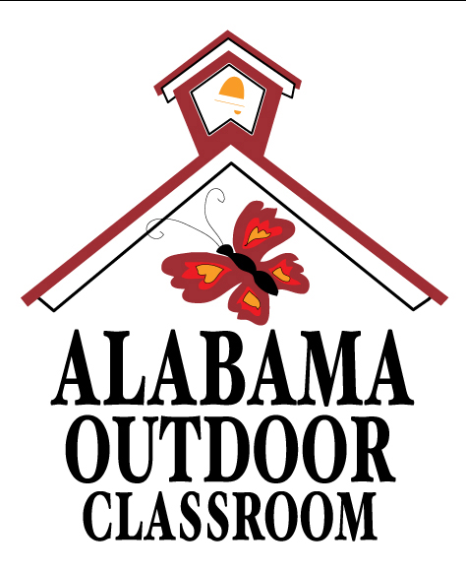
Outdoor Classroom Rules

The purpose of our Outdoor Classroom is to provide habitat (a home) for local wildlife.

Please help us take care of our Outdoor Classroom!
- Students should Always be Accompanied by an Adult
- Do Not Step on or Climb on Rocks or Garden Pavers
- Do Not Remove Wildlife, Plants, Flowers, or Rocks
- Do Not Feed Wildlife without Permission
- No Food or Drinks without Permission
- Do Not Litter
- Do Not Run
- No Pets

Take Nothing but Pictures,
Kill Nothing but Time, and
Leave Nothing but Footprints.

We hope you enjoy your time in our Outdoor Classroom!
Remember – the quieter you are, the greater
your chance of seeing and hearing wildlife!
Please help us keep it free from litter and vandalism.

