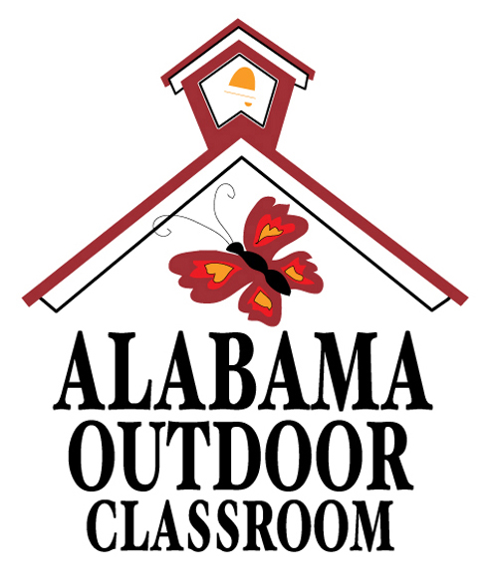
Name of School’s Outdoor Classroom Day
Day, Date, Start Time – End Time
(Alternate Rain Date: Day, Date)

We are working to develop an outdoor classroom site for our students through the Alabama Outdoor Classroom Program that will include (list learning stations such as a butterfly garden, song bird sanctuary, raised bed gardens, weather station, and a frog & toad habitat)—all of which will provide learning stations where our students can participate in hands-on inquiry-based activities. Technical assistance, volunteer time, funds, and materials for our outdoor classroom are provided by the Alabama Wildlife Federation, a ________________ Grant, our “Name of School” PTA/PTO, and (list any other big partners/sponsors).

Parents/Guardians must return the following consent form by Friday, Month Date (10-14 days prior to event), for your child to participate in the Outdoor Classroom Day on Event Date, (rain date scheduled for Rain Date):
I consent to my child’s participation in the Outdoor Classroom Day and to have my child’s photo taken and published relative to the event. I understand that all students must wear closed-toed shoes and outdoor clothing to participate. I release Name of School and the Alabama Wildlife Federation from any liability, personal injury, or property damage that might occur from my child’s participation in this event.
Name of Child:___________________________________________________ Date:____________________
Grade:__________________________ Teacher’s Name:___________________________________________
Name of Parent/Guardian:___________________________________________________________________
Parent/Guardian Signature:___________________________________________________________________

*** VOLUNTEERS ARE NEEDED! DONATIONS ARE NEEDED!! ***
If you would like to assist with the Outdoor Classroom Day on Date, (rain date scheduled for Rain Date), please return this form along with any donations to your child’s teacher by Day, Date (same date as above).
Volunteer’s Name: _________________________________________________________________________
Volunteer’s Phone #:_______________________ Email:___________________________________________
- I would like to VOLUNTEER! I am available during the following time frame: (check all that apply)
❒ 8–9 am | ❒ 9–10 am | ❒ 10–11 am | ❒ 11 am–12 pm | ❒ 12–1 pm | ❒ 1–2 pm | ❒ 2–3 pm
- I will bring the following tools:
❒ shovel | ❒ wheelbarrow | ❒ power drill | - Other:____________________________________
* All volunteers should bring or wear a hat, gloves, closed-toed shoes, and clothes for working outdoors.
- I would like to make a DONATION! I would like to support the following project(s) with…
Song Bird Sanctuary | - $10 for (1) Bird Feeder  - $15 for (1) Large Bag of Birdseed | &/or…  &/or… | - (1) Bird Feeder  - (1) Bag of Birdseed
Raised Bed Gardens | - $20 for Potting Soil & Mulch  - $25 for Plants | &/or…  &/or… | - (1) Bag of Potting Soil  - (1) Flat of Small Annual Plants
*If you have any questions, please contact Name of OC Teacher at her email address.
Please Return this Form by Day, Date. (same as above)
For more info, visit https://www.alabamawildlife.org/outdoor-classroom-program/
Outdoor Classroom Day Student, Volunteer, & Support Form: page 1 of 1 Last Updated: 4.30.20

