
Outdoor Classroom Day Planning Checklist
Your Outdoor Classroom Planning Committee needs to review and finalize the following checklist with your Alabama Wildlife Federation Outdoor Classroom Consultant 4 weeks prior to the Outdoor Classroom Day:
School Name:_______________________________________ Planning Committee Meeting Date:______________
Planning Schedule & Deadlines
Send out Student Forms:________  Receive Student Forms by:_______  Materials Delivery:_________  Prep & Reminder Date:________ | Send Volunteer/Donor Forms:____  Volunteer/Donor Deadline:_______  Plants Delivery:___________  OC Day:___________ | Submit Lowe’s Order:_________  Final Planning Meeting Date:________  Crushed Limestone Delivery:________  Rain Date:___________
OC Day Projects
- Butterfly Garden (size:_______)  - Caterpillar Garden (size:_______)  - Pollinator Garden (size:_______)  - Sensory Garden (size:_______)  - Frog & Toad Habitat (size:_______)  - Log Decomposition Station  - Cardinal Directions Sign  - Weather Station  - ___ Bushes &/or ___ Trees | - ___ Nesting Box(es) / ___ Bird Feeder(s)  - Songbird Garden (size:_______)  - ___ Raised Bed Gardens (size:_______)  - Pitcher Plant Bog (size:_______)  - Rain Garden (size:_______)  - Limestone Path (length:_______)  - Vermiculture Worm Bin  - Compost Bin  - Other:___________________________ | - Educational Signs  - Plant ID Signs  - Student Sundial  - Measuring Wall  - Prune trees & bushes  - Lattice around A/C Units  - Other:____________  - Other:____________
- Projects’ Needs List: List the projects & learning stations to be completed, the amount of time needed to complete the project (half-day or all day), the number of volunteers needed (at least 2-3 per project per time slot), and the number of students that could work together at one time on each project (3-5 students at most due to limited space). Note: Need at least 5 projects with 4-5 students at each project to keep a full class of students engaged.
Learning Station(s) or Activity | Project Zone # | Est Time to Complete  (½ day/ full day) | # of Volunteers Needed  (each time slot) | # of Students Needed  (each time slot) | Tools  Needed
- Total # of Volunteers Needed per Time Slot:________
- Total # of Students per Time Slot:_____ Students …OR… (1) One Class per Time Slot (at most)
Outdoor Classroom Day Checklist: page 1 of 4
- Project Leaders: Each project will need an adult to lead and supervise the project throughout the entire day. If possible, planning committee members could volunteer to lead different projects if subs are available.
Name of OC Build Day Project | Project Leader Name
Who will help manage volunteers | Alabama Wildlife Federation OC Consultant:
Will help manage class rotation schedule | OC Coordinator:
OC Day Schedule
Include 30 minute time slots for each group/class, 5-10 minutes for transition time between time slots, and 30 minutes of NO children for the volunteers’ lunch. Teachers must accompany their students – No drop-offs. Be sure to include teachers’ names, grade levels, and the total number of students that will participate in each time slot.
Time Slots | Example Schedule  for 10 Classes | Example Schedule  for 9 Classes | Schedule | Teacher Name(s) | Grade(s) | Total # of Students
1 | 8:00 am – 8:30 am | 8:15 am – 8:45 am
2 | 8:35 am – 9:05 am | 8:50 am – 9:20 am
3 | 9:10 am – 9:40 am | 9:25 am – 9:55 am
4 | 9:45 am – 10:15 am | 10 am – 10:30 am
5 | 10:20 am – 10:50 am | 10:35 am – 11:05 am
6 | 10:55 am – 11:25 am | 11:10 am – 11:40 am
7 | *Lunch  11:30 am – 12 noon | *Lunch  11:45 am – 12:15 pm
8 | 12:05 pm – 12:35 pm | 12:20 pm – 12:50 pm
9 | 12:40 pm – 1:10 pm | 12:55 pm – 1:25 pm
10 | 1:15 pm – 1:45 pm | 1:30 pm – 2:00 pm
11 | 1:50 pm – 2:20 pm | Clean Up until 3 pm
12 | Clean Up until 3 pm
Students / Classes
Send out & collect student consent forms at least four weeks prior to the event. Review & edit template.
Each teacher is responsible for collecting their own students’ forms.
Students without forms or closed-toe shoes are not allowed to participate in activities that use equipment such as shovels, but they can help move crushed limestone or plant flowers.
- Which planning committee member will handle printing & distributing Student Forms?_________________
- Deadline to send to Students’ Guardians: ____________________ Deadline for Return:___________________
- Put student forms on same piece of paper as Volunteer/Donation form? ___Yes ____No
Outdoor Classroom Day Checklist: page 2 of 4
Volunteers, Donations & Tools
Send out & collect Volunteers & Donations forms at least four weeks prior to the event. Review & edit template.
Volunteers should wear outdoor clothes and closed-toe shoes, and bring shovels, wheelbarrows & other equipment.
These forms, donations and tools should be collected by an OC Planning Committee member.
- Who will handle printing, distributing & collecting the Volunteer / Donations Forms?_________________
- Volunteer / Donations Form: __Paper …or... __Google Form …or... __Both
- Deadline to send to Potential Volunteers/Donors: ______________ Deadline for Return:_______________
- Who will collect the donations?_________________________ Tools?________________________________
- Where & when will you collect Donations & Tools?_________________________________________________
- Volunteers, Donations & Tools List: Put the volunteers’ names with their email addresses and time slots in a chart, and finalize the list & schedule the week before the event. Volunteer shifts should begin at 8 am to help with setting up and should end around 3 pm to help with clean up. Need at least 2-3 volunteers at each learning station during each timeslot, with at least 5 strong volunteers present at all times if there is a lot of digging that day.
- Date to Email Volunteers, Donations & Tools List to Consultant (at least 1 week before event): _________________
Volunteer Name | Email Address | Available Time Slots | Tools | Donations
- Volunteer Supplies: Remind volunteers to bring hats, gloves, sunscreen, extra water/gatorade, shovels, wheel borrows, and other equipment (if needed). Also, remind parents to wear appropriate clothes and closed-toe shoes.
Date to Email a Reminder to Volunteers: _______________
- Volunteer Tent, Table, Drinks, Snacks & Lunch: Need tent for shade; sign-in table (for thank you notes); coolers with water/Gatorade; snacks & lunch for volunteers. Ask PTA/PTO or local businesses to donate the food and drinks.
Who will provide Tent?____________________ Table(s)?___________________ Chair(s)?________________
Sign-in List?_______________ Name Tag(s)?______________________ Other?________________________
Who will provide Drinks & Snacks:_____________________ Where will they be set up?___________________
Who will provide Lunch: ____________________ Where will you provide Lunch:________________________
Who will provide Shoes & Tools Washing Station:______________________ Where?_____________________
Participant Reminders
- Student Reminder: On the day before the OC Day, participating teachers should email and/or send a note to remind parents that students should wear appropriate clothes and closed-toe shoes. They can bring garden gloves if needed.
- Volunteer Reminder: On the day before the OC Day, email and/or text your volunteers a reminder:
(1) Bring gloves & water/Gatorade.
(2) Wear appropriate outdoor clothes and closed-toe shoes.
(3) CHECK IN at Front Office (or at Volunteer Tent in OC) before coming to outdoor classroom.
(4) Bring a shovel & wheel borrow with your last name written on them with duct tape.
Date to Send Reminder to Students, Parents & Volunteers (day before OC Day): _____________________
Outdoor Classroom Day Checklist: page 3 of 4
- Digging & Utilities: The Buildings & Maintenance Supervisor must mark underground utility lines (gas, electric, water, sewer, phone, cable & sprinkler) with spray paint or flags 2-3 days prior to the event. (Only required if the Buildings/Maintenance Department have NOT provided a map of the utility lines.)
Who will handle Utility Lines:__________________ Deadline for Painting Utility Lines:______________
- Learning Station Materials: Review the list of materials that are needed to complete the OC Day projects. All materials must be ordered within at least two weeks from the event and must be delivered at least two days BEFORE the event so they can be inventoried & organized by the AWF OC Consultant before the event.
Who will handle Materials Order:_____________________ Which you use Lowe’s?________________
Materials Order Deadline:______________________ Delivery Deadline:________________________
- Perennial Plants, Annuals, Bushes & Trees: Review the list of plants that are needed to complete the OC Day projects. The OC Consultant will arrange for the native plants to be provided by a local nursery. You will be provided with a Quote and then once a PO # is provided, you will be provided by an Invoice. Your AWF OC Consultant will help make arrangements to pick up and deliver your plants.
Plants Order Deadline:_____________________ Delivery Deadline:________________________
- Crushed Limestone for Pathways: Your AWF OC Consultant will calculate the amount of crushed limestone you need to order and provide you a . All materials must be ordered within at least two weeks from the event and must be delivered at least two days BEFORE the event so they can be inventoried & organized by the AWF OC Consultant before the event.
Who will handle Materials Order:_____________________ Which you use Lowe’s?________________
Materials Order Deadline:______________________ Delivery Deadline:________________________
- Press Release: Your OC Consultant will create a press release for your OC Day. Once you update and approve it, email the finalized version back to your consultant. Your school &/or school system should send out the finalized press release to your media contacts 5-7 days prior to the event. It also helps to call the media with a reminder the day before the event. Media will respond to local schools more than the AWF since we do not have an office here.
Date to Email to School for Review: ______________ Date to Send to Local Media Contacts: ______________
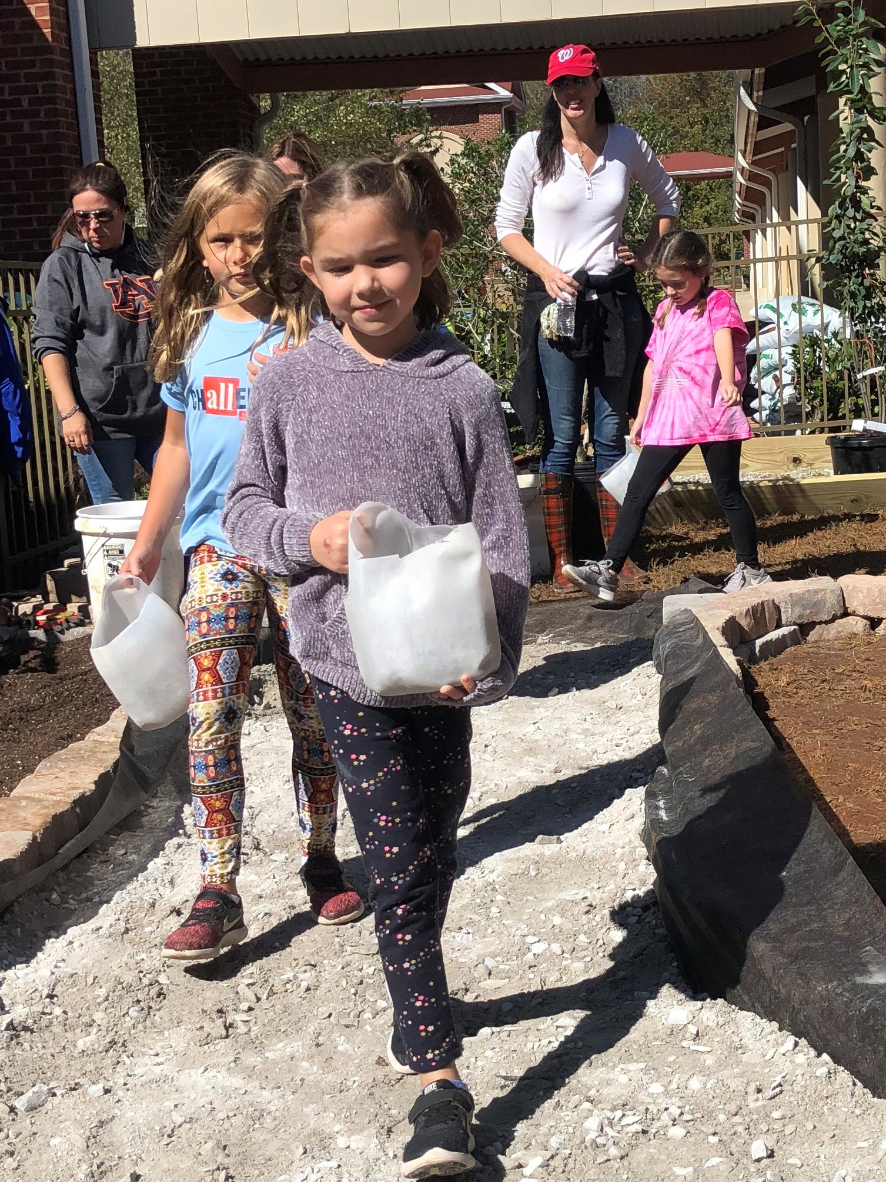
- Dirt Removal Location (where grass clumps should be taken): _______________
- OC Day Supplies: Review this list with the committee one week prior to Build Day to identify needed supplies. Provide these supplies by 7:30 am on OC Day:
- 25 durable 1-gallon milk jugs (with handles but no top) for students to transport materials such as crushed limestone, mulch, or soil;
- 1-2 strong/sturdy wheel borrows for each learning station;
- 5-6 shovels for each learning station;
- 1-2 extension cords, drills, saws, saw horses & other construction equipment;
- 1-2 cameras to record the progress made during the OC Day;
- 2-4 hoses for filling pond, filling bog, or watering trees, bushes and flowers;
- 1-2 large lined garbage cans with extra trash bags for trash and debris.


Contact your Alabama Wildlife Federation Outdoor Classroom Consultant with questions:
North Alabama: April Waltz, aprilwaltz@alabamawildlife.org, 256.975.1852
Central Alabama: Allison Mathis, amathis@alabamawildlife.org, 334.832.0411
South Alabama: Tyler Burgener, tburgener@alabamawildlife.org, 334.318.8904
Outdoor Classroom Day Checklist: page 3 of 3 Last Updated: 1.30.23

