Animal Adaptations & Behaviors for Reproductive Success
Your Name: | ____________________________________________

DID YOU KNOW?

Adaptation: The Killdeer has a brown back, white belly, and black-striped neck that allows it to blend in with its environment to hide from predators.
Behavior: The Killdeer lays its eggs on open ground, often in gravel or rocks, without a nest.

Adaptation: Killdeer eggs are speckled and colored in a manner that camouflages them with the gravel and rocks around them, which makes it harder for predators to find the eggs.
Behavior: If a parent Killdeer spots a predator nearby, it will call loudly and pretend it has a broken wing as it lures the predator away from the eggs.
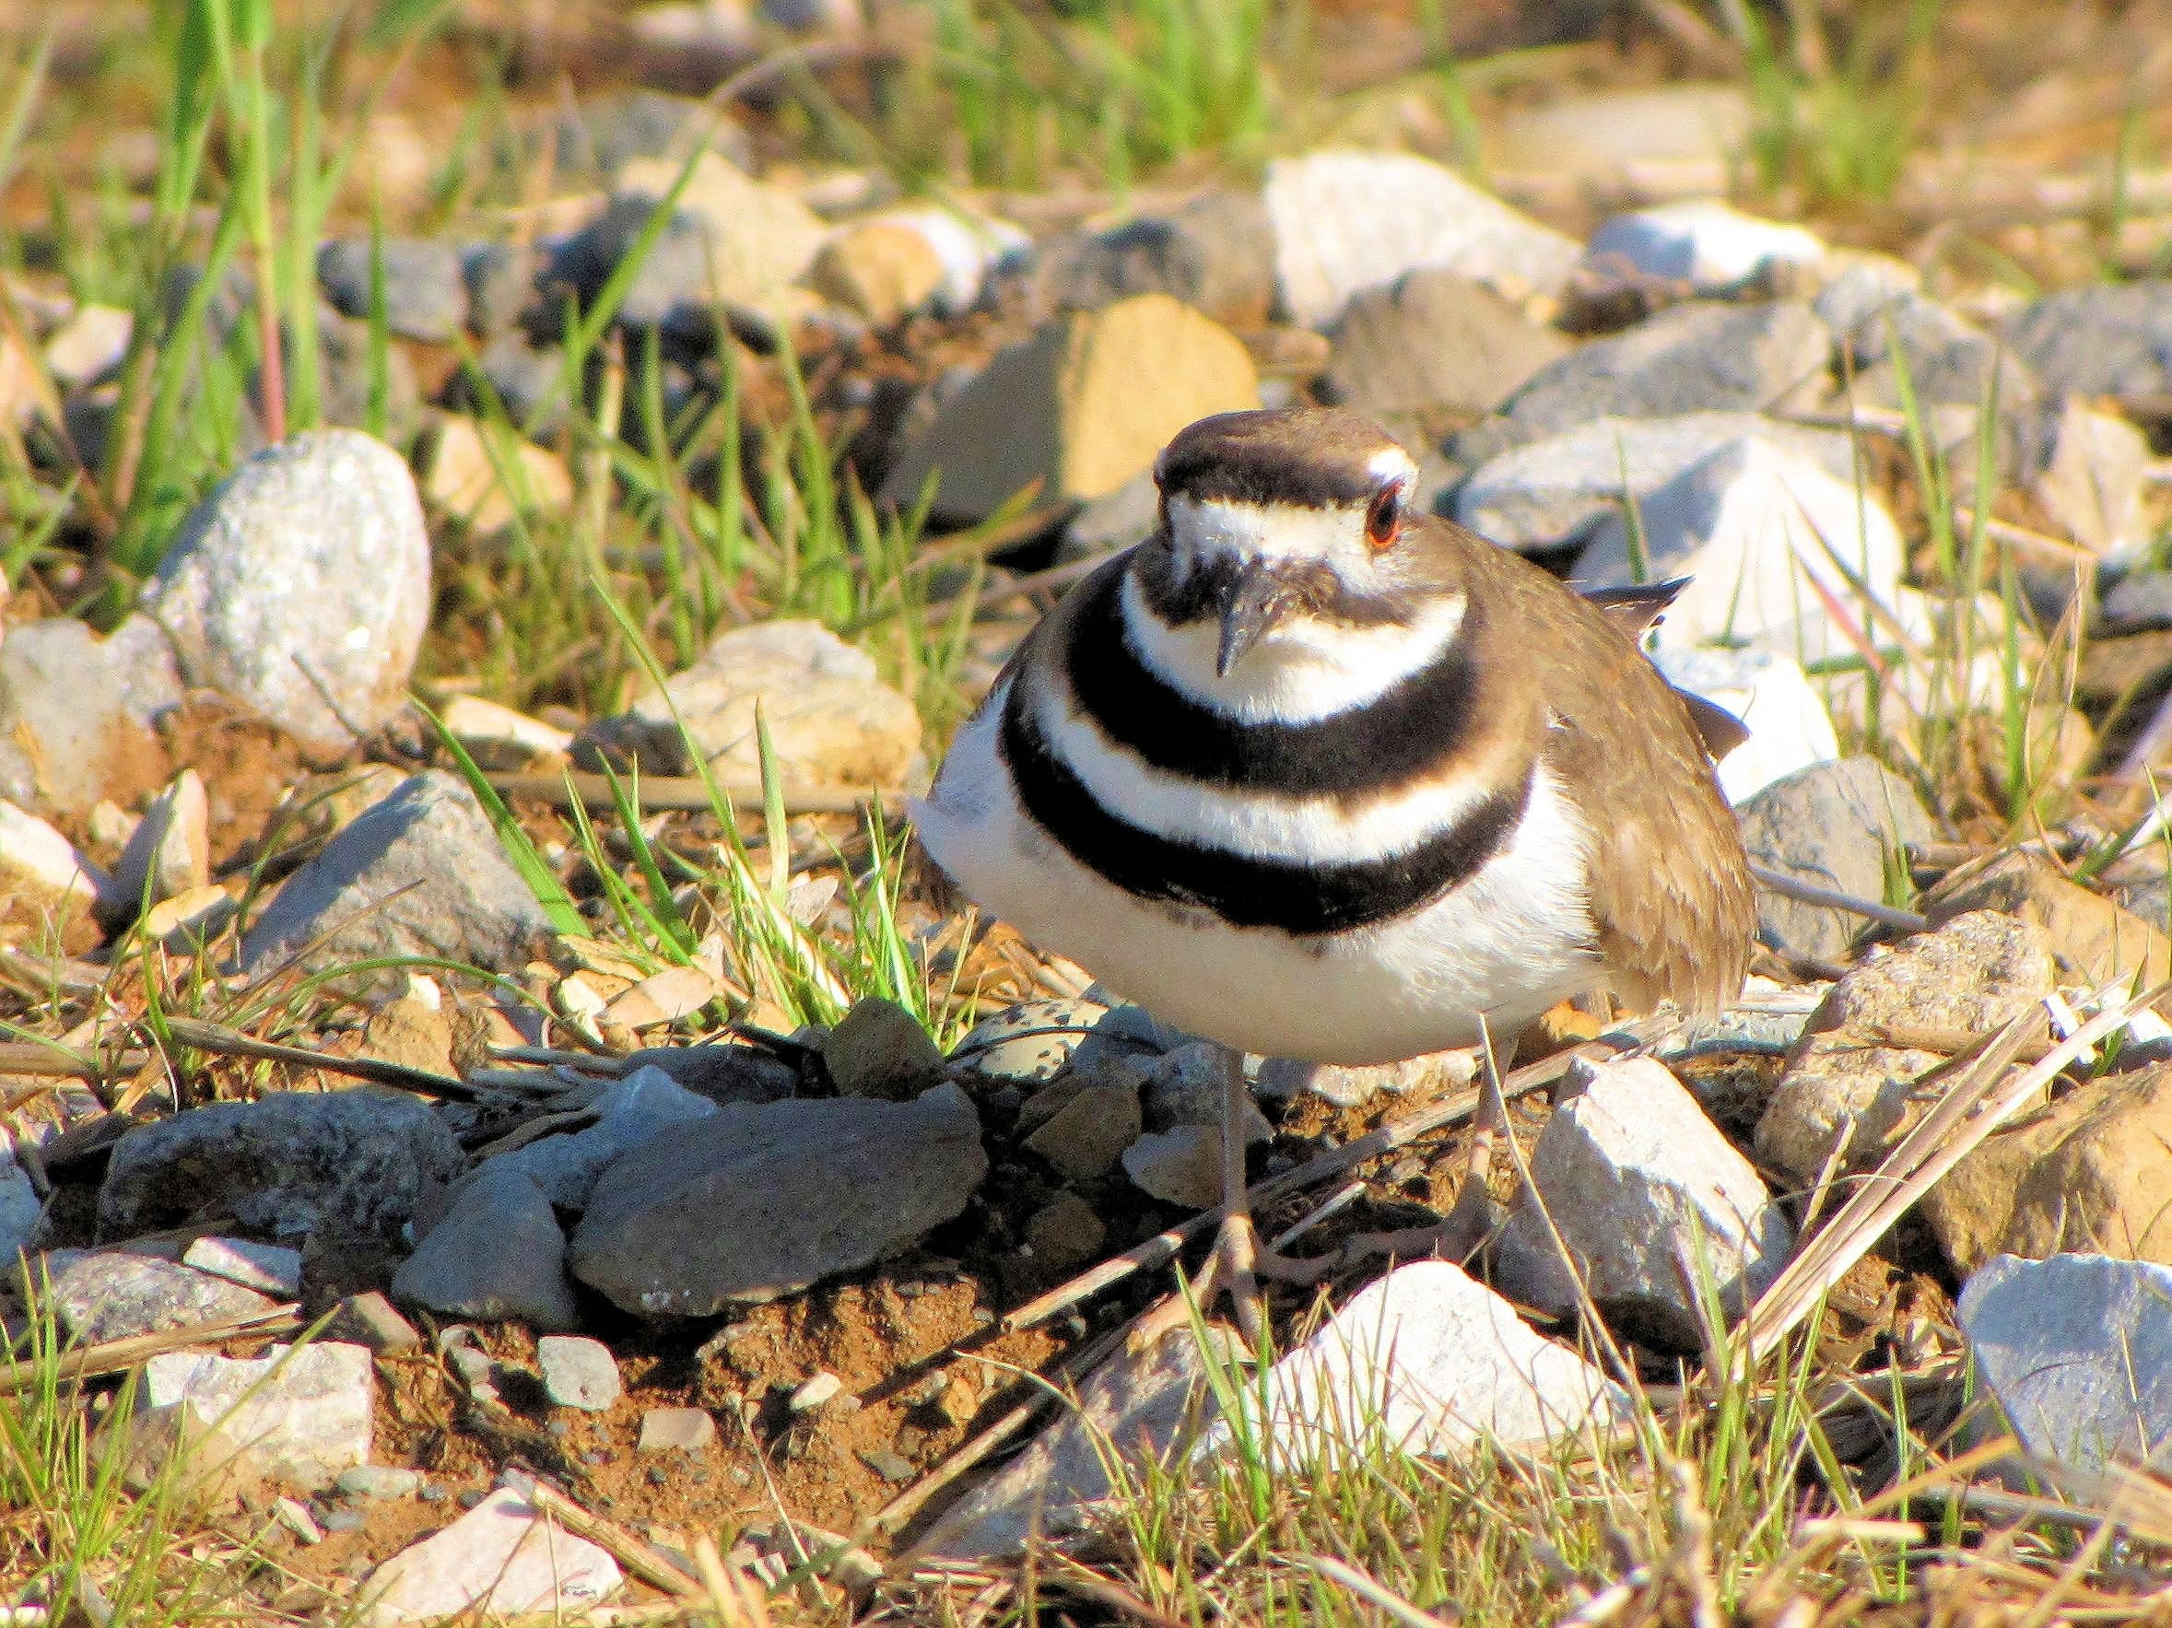
Successful reproduction occurs when animals mate, babies are born, and the young survive. Nearly all animals have physical adaptations and behaviors that increase their likelihood of successful reproduction.

Take a walk in your outdoor classroom to observe animal adaptations and behaviors that you think may affect reproduction. Answer the questions below and support you answers using scientific reasoning. You may research the species of animal you observed to learn more about its adaptations and behavior.
Alabama Wildlife Federation Outdoor Classroom Field Journal Activity: Animal Behavior & Adaptations, page 1 of 2
1) What animal do you see? Try to determine the specific species using field identification guides if possible.

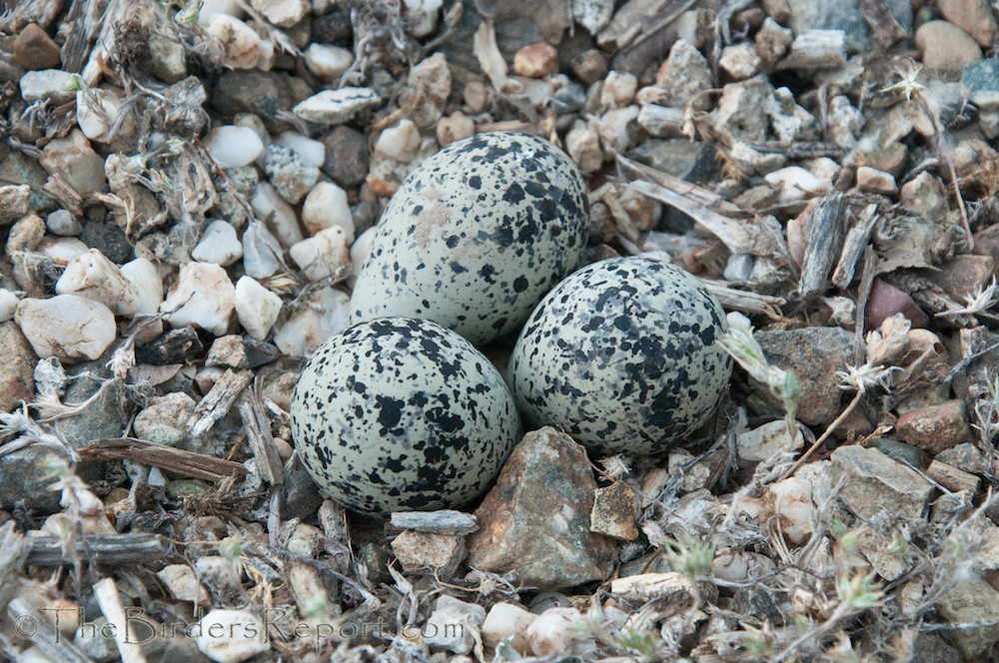
2) What physical adaptation(s) does it have that increases its likelihood of successful reproduction?

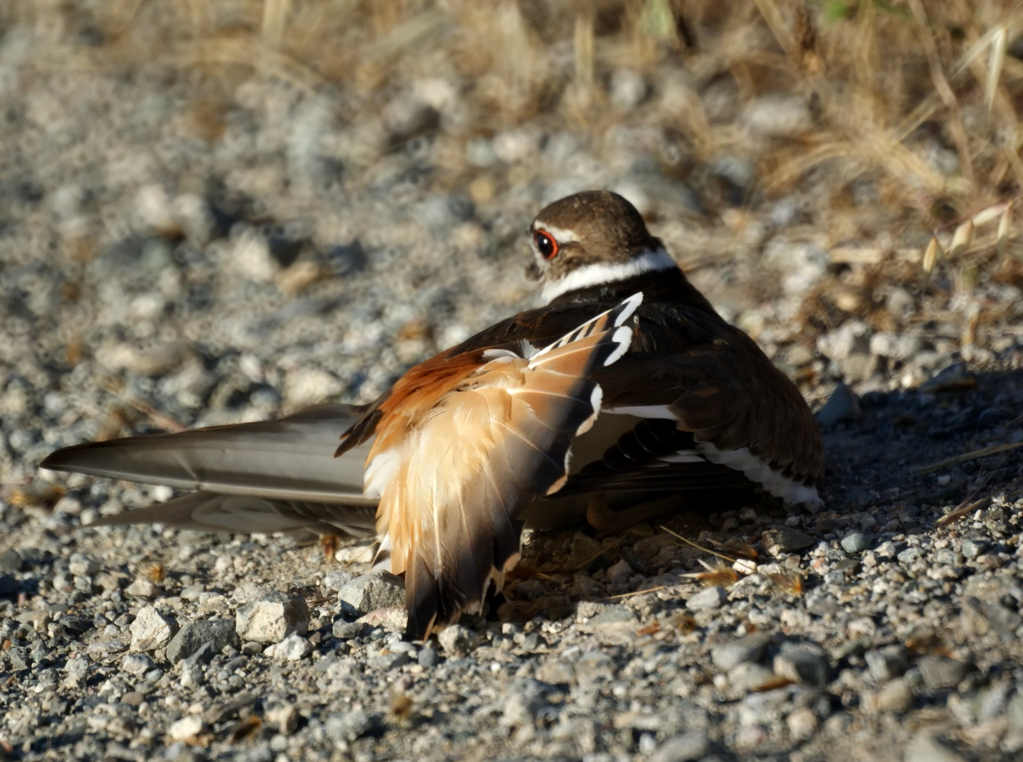
Alabama Wildlife Federation Outdoor Classroom Field Investigation: Animal Adaptations & Behaviors, page 1 of 2

3) How does its physical adaptation(s) increase the animal’s probability of successful reproduction? Explain in terms of cause-and-effect.

4) What behavior does it display that increases its likelihood of successful reproduction?

5) How does its behavior increase the animal’s probability of successful reproduction? Explain in terms of cause-and-effect.

6) If you had a longer period of time to observe the animal, what evidence might you be able to gather to support your claim? Using scientific reason, explain how the evidence would help prove or disprove your claim?

Alabama Wildlife Federation Outdoor Classroom Field Investigation: Animal Adaptations & Behavior, page 2 of 2

