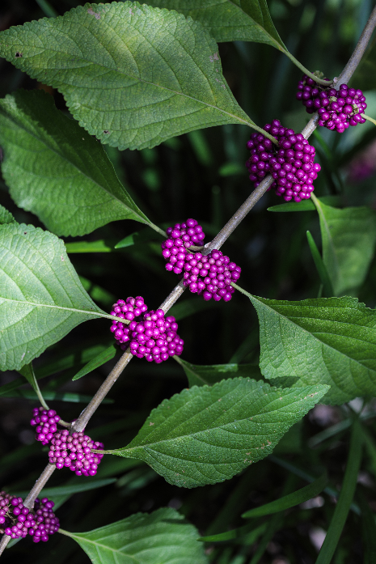

**American Beautyberry**

*Callicarpa americana*

Food for Birds

Native to Alabama