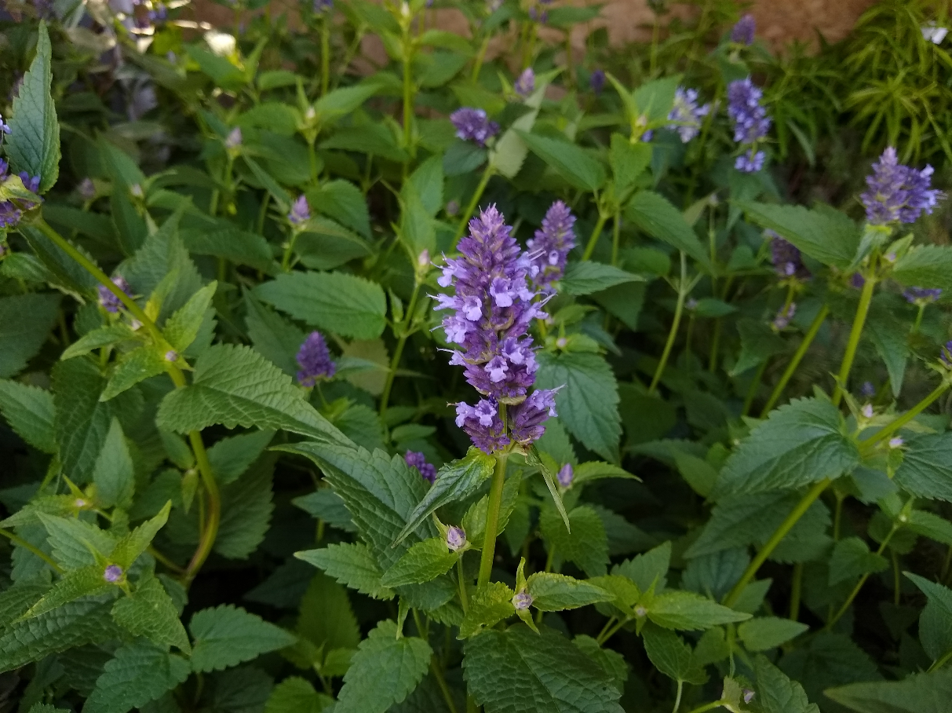

**Anise Hyssop**

*Agastache foeniculum*

Food for Birds

Native to Alabama