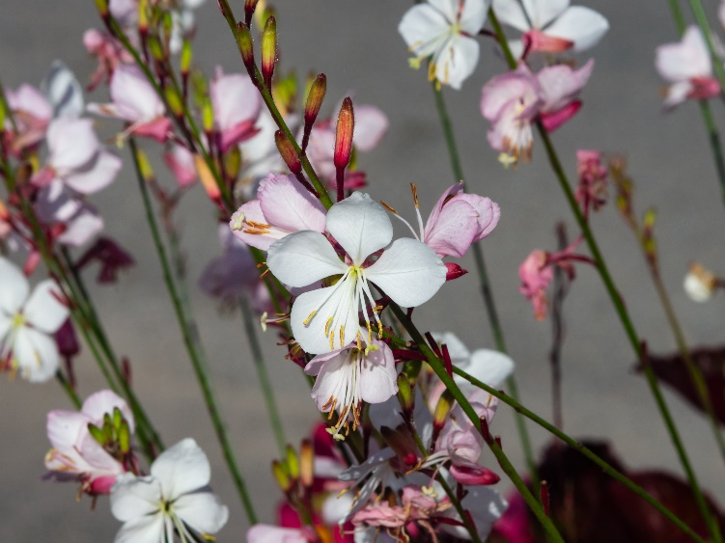

**Beeblossom**

*Oenothera lindheimeri*

Nectar Plant

Non-native