Native to Alabama

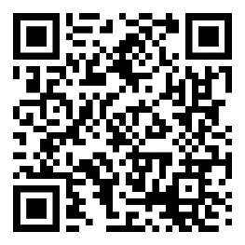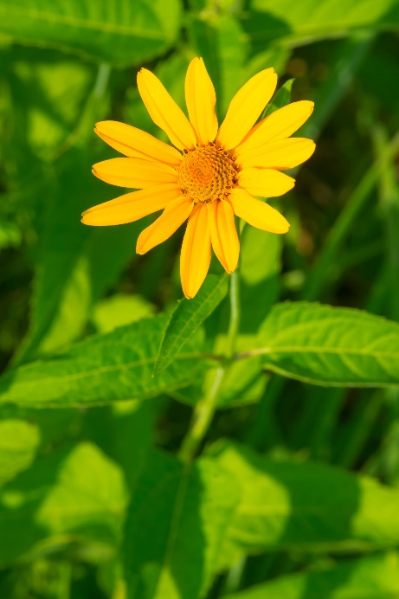

**False Sunflower**

*Heliopsis helianthoides*

Seeds &   
Nectar Plant