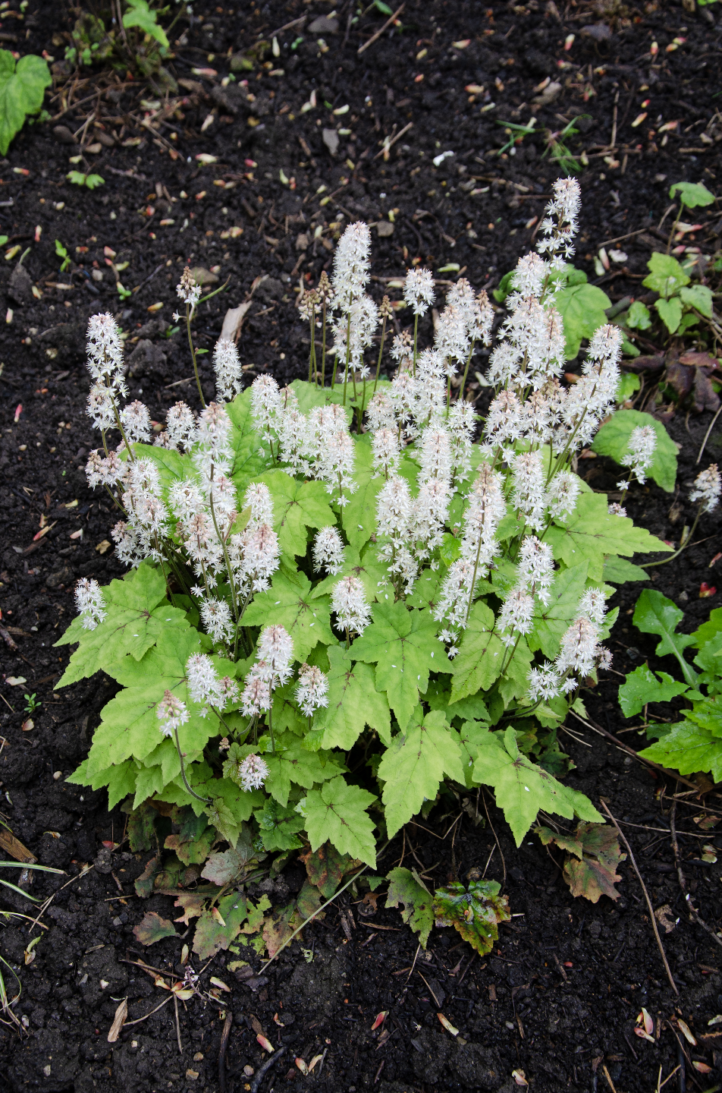

**Heartleaf Foamflower**

*Tiarella cordifolia*

Nectar &   
Cover Plant

Native to Alabama