**Lamb’s Ear**

*Stachys byzantina*

Touch My Leaves

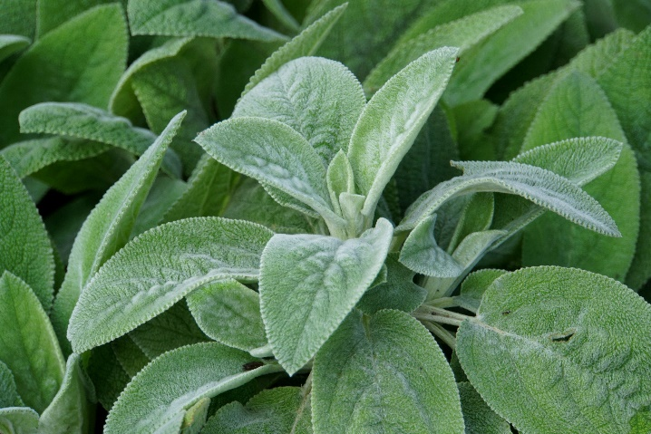

Non-  
native