**New England   
Aster**

*Symphyotrichum novae-angliae*

Host & Nectar Plant

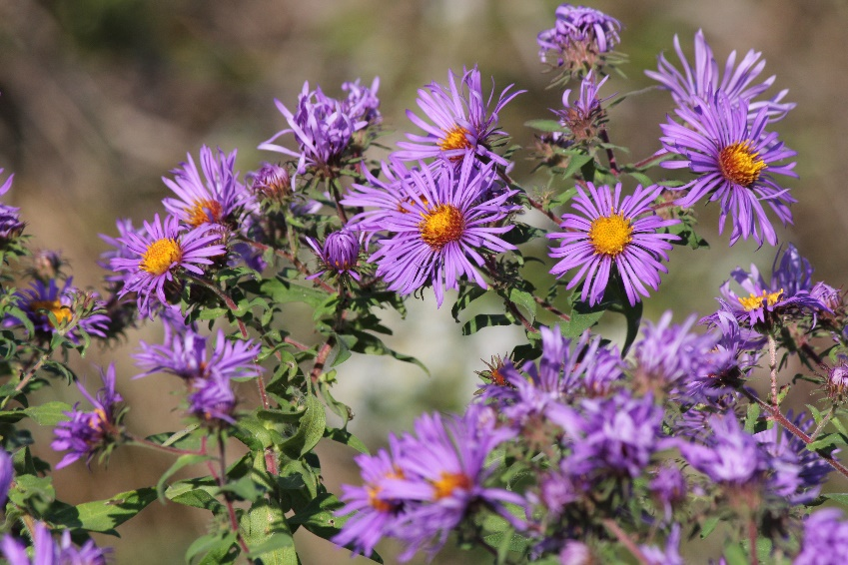

Native to Alabama