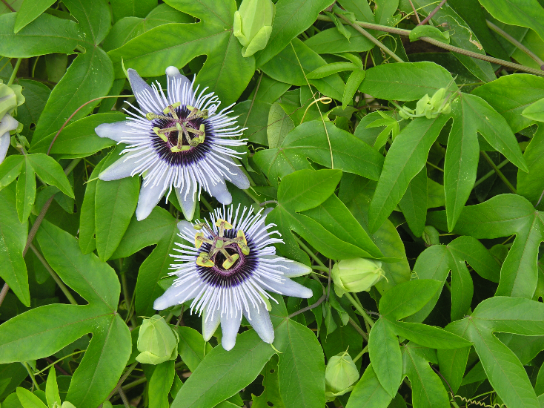

**Passionflower**

*Achillea millefolium*

Nectar &  
Host Plant

Native to Alabama