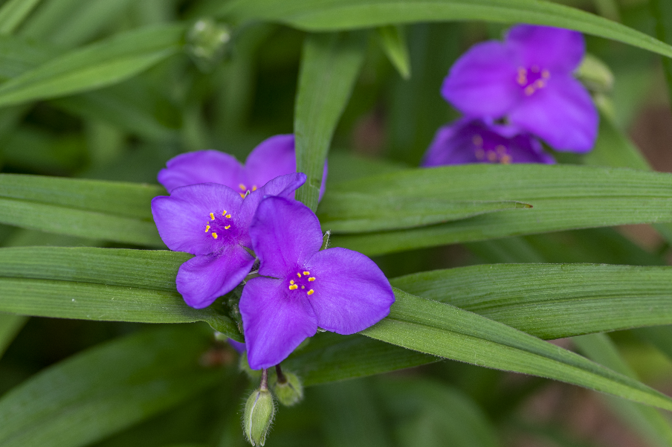

**Spiderwort**

*Tradescantia occidentalis*

Shade Plant

Native to Alabama