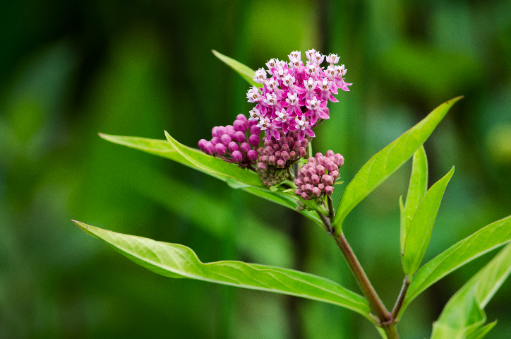

**Swamp Milkweed**

*Asclepias incarnata*

Nectar & Host Plant

Native to Alabamac