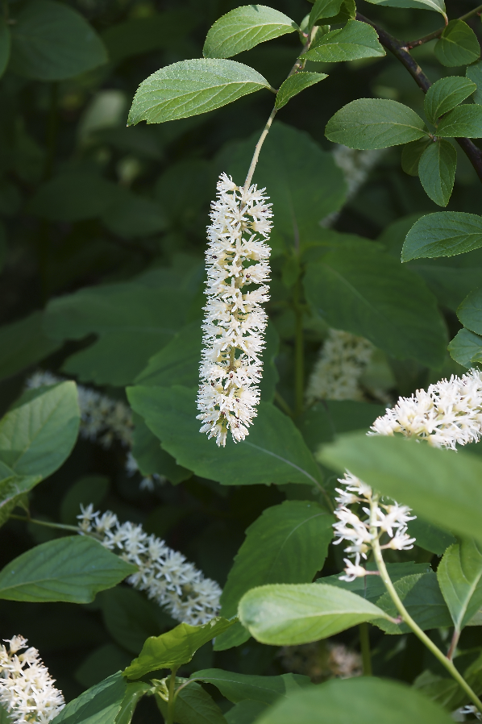

**Virginia Sweetspire**

*Itea virginica*

Nectar & Shelter   
Plant

Native to Alabama