

**Yaupon Holly**

*Ilex vomitoria*

Shelter & Food   
for Birds

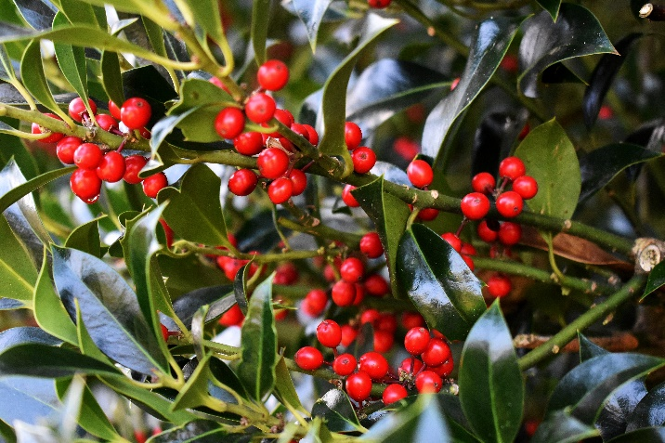

Native to Alabama