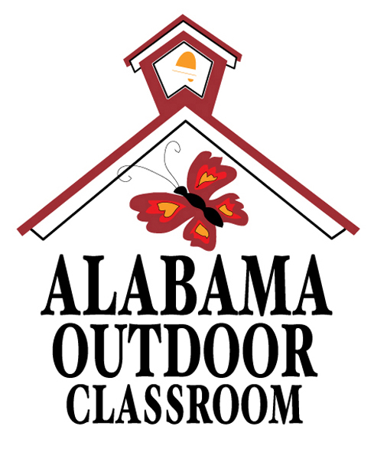
Alabama Outdoor Classroom Program
Pollinator Garden Fall Maintenance Checklist
Below are the supplies/tools needed to complete each maintenance task along with an estimated cost, an estimated amount of time needed to accomplish each task, and the frequency each task should be done.
Task Description | Supplies/Tools Needed | Estimated Cost | Est. Time Needed | Frequency of Task
WEEKLY FALL MAINTENANCE TIPS
Deadhead annual flowers to encourage further blooming, but leave plant stems as they are used as egging laying tubes by some pollinators. | n/a | n/a | 15-30 min | Once per week
Pull weeds and clean out the garden. | Gloves | n/a | 15-30 min | Once
Water as needed. If it hasn’t rained, water to a depth of approximately 2” twice per week. | Garden Hose | n/a | 15-30 min | Twice
Keep hummingbird feeder(s) clean and filled. | 1:4 Sugar water | $5 | 15 min | Twice
AUGUST
Update your Pollinator Garden Plant ID Map if needed. Contact your OC Consultant or Master Gardeners for ID assistance. | Your Pollinator Garden Plant ID Map | n/a | Up to 1 hour | Once
Remove diseased/damaged plants. Contact your local ACES Extension office for advice. | Gloves & Pruners | n/a | 30 min | Once
SEPTEMBER
Watch for increasing numbers of hummingbirds. Report sightings on Journey North’s website. | n/a | n/a | 15 minutes | Twice per week
Leave seed heads on dying or dead plants as food for birds. Ex. Black-eyed Susans and Coneflower | n/a | n/a | n/a | Once
Check paint/sealer on items such as plant ID signs. Touch up if needed. | Paint and/or Sealer | $5-10 | 1 hour | Once
OCTOBER
Divide and share perennials plants if overgrown, and replace dead perennials if needed. | Hand Spade or Small Shovel | Plant costs Vary | 30 min - 1 hour | Once
Add newspaper as a weed barrier around plants & lay mulch on top to help protect plants in winter. | Mulch and Newspaper | $2 per cu. ft. bag | 30 min - 1 hour | Once
NOVEMBER
Collect remaining seed heads for spring planting. | n/a | n/a | 15 min | Once
Remove dead plant material after the first frost. | Gloves | n/a | 30 min | Once
DECEMBER
Update the Garden Plant ID Map if needed. | Plant ID Map | n/a | 15 min | Once
Alabama Outdoor Classroom Program: Pollinator Garden Fall Maintenance Tips 072019

