 **Outdoor Classroom Project Plan:**

**Construction Instructions for**

**Simple Songbird Sanctuary**

* **Construction Tools & Supplies for Outdoor Classroom Build Day:**
* (8) Shovels (4 for adults & 4 for children)
* Pick ax for removing large rocks if necessary
* (1-2) Wheelbarrows for moving grass clumps, soil & mulch
* (24-30) 1-gallon milk jugs (with tops cut off but handles remaining) for students to move excavated dirt, sand, soil, etc.
* (4-6) Hand-held trowels (for stirring soil amendments together)
* Water hose for watering plants at end of day
* Saw for cutting 4” x 4” post into (4) 6” pieces for Plant ID Signs
* (1) Speed Square for measuring angle for the top of the 4” x 4” posts for Plant ID Signs
* Drill for attaching signs to posts
* **Construction & Planting Instructions:**

1. Purchase supplies and have them on-hand for the Outdoor Classroom Build Day.
2. Decide where you want to plant your tree(s), bushes, &/or other plants, and place the plants in those locations. Spray-paint a circle twice the diameter of each plant’s pot.
3. Plant the tree(s). *See Alabama Cooperative Extension Publication ANR-1405 for tree planting instructions.* (<https://ssl.acesag.auburn.edu/pubs/docs/A/ANR-1405/ANR-1405-archive.pdf>)

* Dig a hole 2-3 times the width of the root ball of the tree and three inches deeper than the height of the root ball.
* 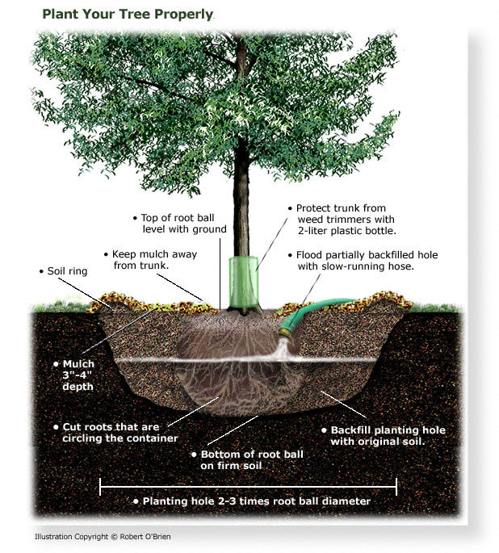Mix the soil that has been excavated with the potting soil to create an enriched and aerated soil for the tree to grow in.
* Loosen the soil at the bottom & sides of the hole, then add 3 inches of the enriched soil into the bottom of the hole.
* Remove the tree from the pot and loosen the roots by hand. If the roots wrap around the root ball, try to loosen them or cut them so that they can spread outward. If the tree is in a burlap ball, place the tree in the hole and then carefully cut the burlap bag and let it fall into the hole. The burlap will biodegrade with time.
* Place the tree in the hole, making certain that the trunk of the tree is straight and not leaning to one side. The top of the root ball should be even with the ground or slightly higher by no more than an inch.
* Fill the hole around the root ball with the enriched soil (1 bag of potting mix for each tree), and then thoroughly soak it with a hose for 5-10 minutes.
* Once it is saturated, slightly press your foot on the soil around the root ball to help stabilize the root ball and to remove potentially harmful air pockets in the soil.
* Cover the area with 2-3 inches of mulch and water thoroughly twice a week for the first few months.

** Example Simple Songbird Sanctuary Construction Instructions**

* 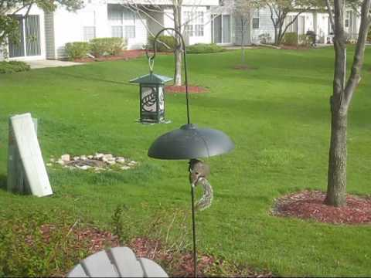**Construction & Planting Instructions (cont.):**

1. Plant the fruit-bearing & evergreen shrubs following the same steps as those for planting the tree (above) using ½ bag of potting mix for each shrub or bush.
2. Choose a spot for your bird feeder station(s) that is at least six feet from the closest tree or limb to help keep squirrels from jumping on the bird feeders. If possible, pick a location in front of a hall window where students can watch the birds. Install the bird feeder station(s) with shepherd hooks and a baffle half way up the pole.
3. Fill the bird feeders with seed, suet, meal worms, fruit, etc., and then attach each bird feeder to a shepherd’s hook.

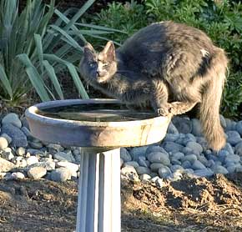

1. Install the bird bath and add water to the basin. Install the solar fountain. Select bird bath location at least 6 feet from trees and bushes so that predators such as house cats cannot ambush the birds in the bird bath.
2. 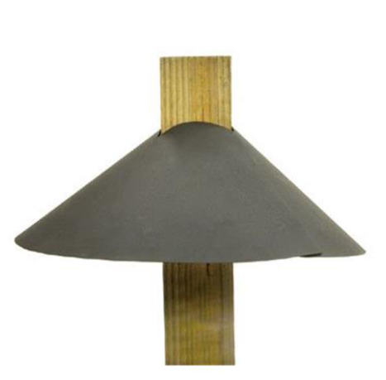Choose locations for bird houses (or nesting boxes) that are as far apart as possible while still remaining in the outdoor classroom area. If you are installing multiple bluebird boxes, you will want to choose locations   
   at least 50-100 yards apart, preferably so that bluebirds using the two   
   nesting boxes cannot see each other.
3. Attach bird houses to top of 4” x 4”’s. Install baffles. Dig 1-ft-deep hole to install 4” x 4”’s one foot in the ground to stabilize the bird houses (or nesting boxes). Use concrete around the base of the 4”x4” in the hole if needed; if not, then pack dirt back in hole around the base of the 4” x 4”.
4. Dig a 1-ft deep hole near the sanctuary for your educational sign, place a 4”x4”x6’ post in the hole, use concrete to secure the post in the hole and around the base of the post to prevent water from collecting and rotting post. Attach educational sign to post.
5. Cut remaining 4” x 4” x 6’ into (12) 6” pieces. Use the Speed Square to cut one end of each 6” piece at a 40-50-degree angle to create a slanted top for your Plant ID signs.
6. Attach each Plant ID sign to the slanted tops of the 4” x 4” x 6” pieces (using screws or adhesive). Sink the bottom of the posts a few inches into the ground in front of the appropriate plant species grouping.
7. Water all of the new plantings thoroughly.