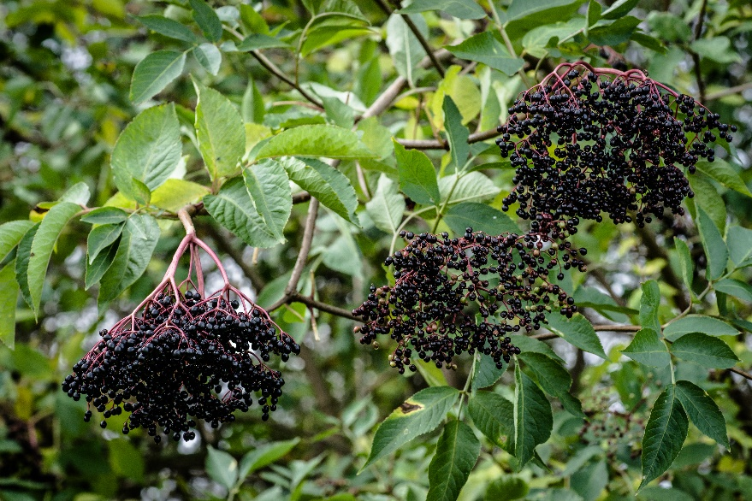

**Elderberry**

*Sambucus canadensis*

Food for Birds

Native to Alabama