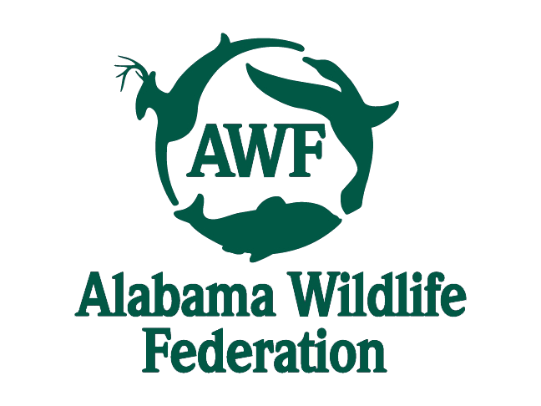

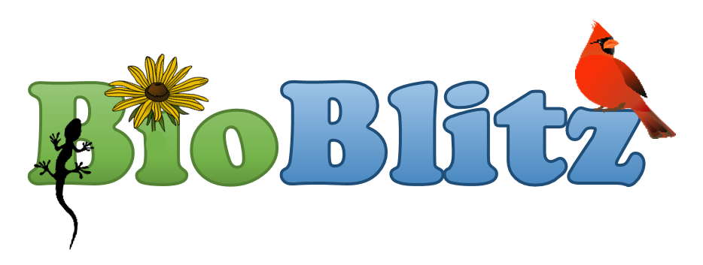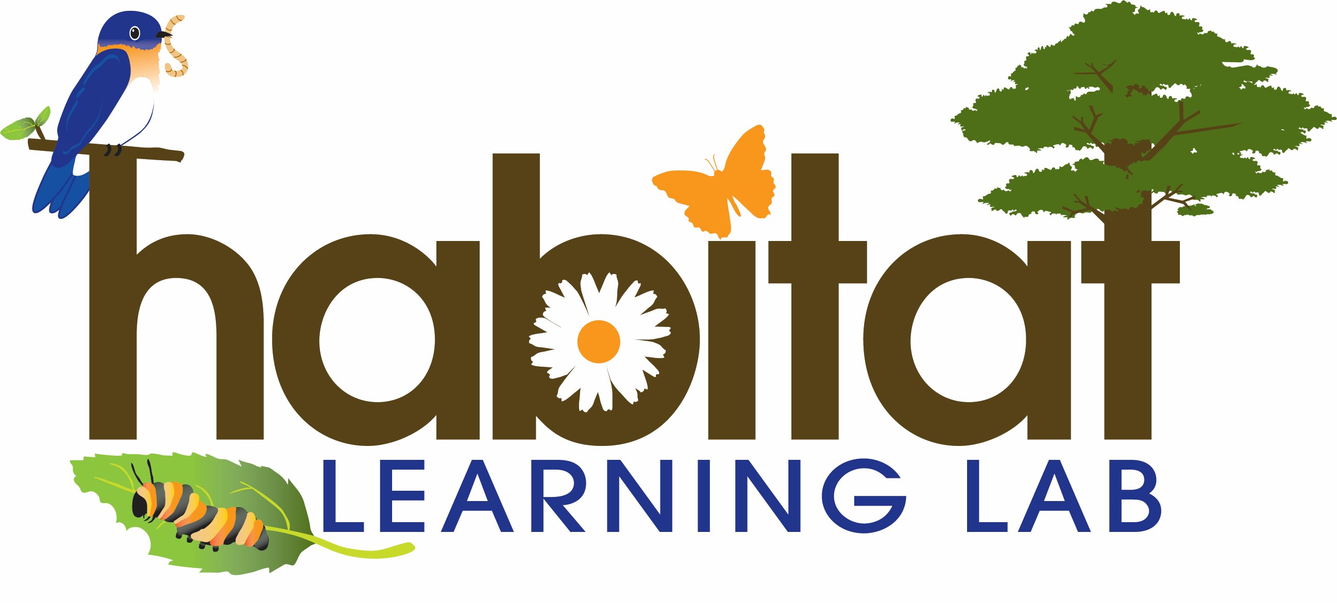

Citizen-Science Excellence Award

National Geographic Society, Alabama Wildlife Federation, Alabama Cooperative Extension System and <Name of School>

present this award honoring your participation in the

Alabama Outdoor Classroom BioBlitz Challenge

**(Participant Name)**

On this <date>.

Teacher Signature: ________________________________________

