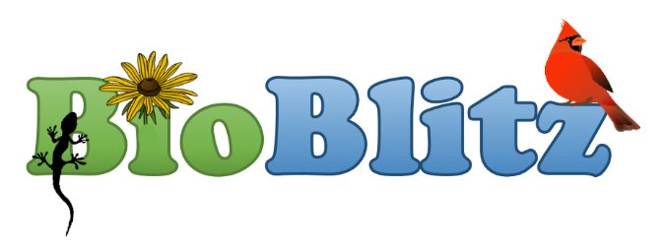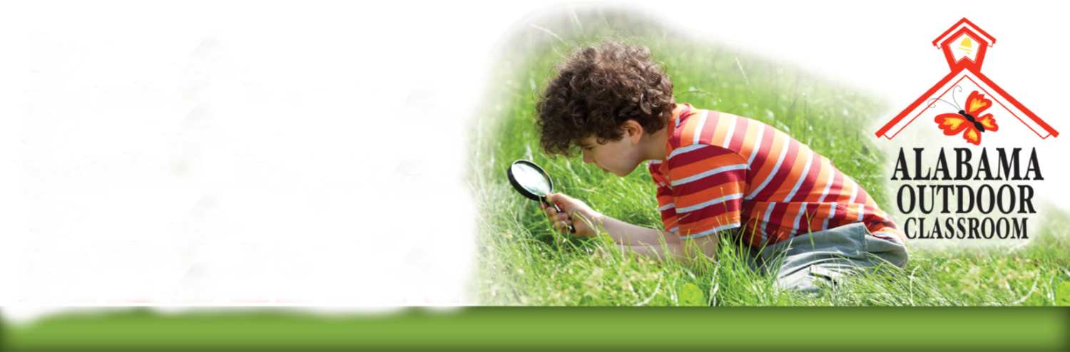

**Who?**

**Your class, your student club or your whole school can participate.**

**What?**

**A BioBlitz is a**

**Biodiversity Treasure Hunt!**

**Where?**

**Explore your Habitat Lab and school grounds to find local flora and fauna that use your campus as their habitat.**

**When?**

**Hold your BioBlitz during the spring or fall when wildlife is still active and plants still have leaves.**

**Why?**

**A BioBlitz is a fun, interdisciplinary, engaging, hands-on activity that gets students outdoors!**

**Hold a BioBlitz at your School!**

**What is the Habitat Lab BioBlitz?**

An opportunity for schools with habitat labs used as outdoor classrooms to participate in a BioBlitz in which students, teachers, parents and community volunteers work together to find, identify and report the flora and fauna species on your school grounds.

**How can your school participate?**

Contact your local Habitat Lab Consultant…

* to receive free assistance on the day of the event
* to receive free organizational support to help you plan your event (for active Habitat Lab Members only).

**Habitat Lab BioBlitz Participation Benefits**

* Students will learn about the classification and taxonomy of plant and wildlife species native to Alabama.
* Students will become Citizen Scientists as they use technology and non-fiction field guides to record, identify, and report their data.
* You will have a biological inventory of the flora and fauna found on your campus that you can update anytime in the future to monitor the biodiversity of your campus.

**For more Information**

**Questions?**

April Waltz

[aprilwaltz@alabamawildlife.org](mailto:aprilwaltz@alabamawildlife.org)

Tyler Burgener

tburgener@alabamawildlife.org

Allison Mathis

amathisr@alabamawildlife.org

Avy Elmore

aelmore@alabamawildlife.org

For more information and free resources to help your school hold a BioBlitz on your campus, visit the AWF’s website at https://www.alabamawildlife.org/habitat-lab-bioblitz/.

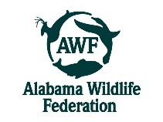The Habitat Learning Lab Program is provided by the Alabama Wildlife Federation